Cryptonite TP2 picoCTF writeup

Sai Rithvik Nama

Note: titles with (!) indicate challenges where I’ve almost completely(>=75%) used write-ups, titles with (!) indicate challenges where I’ve looked at write-ups for hints but have >=75% myself.

**login**  
Hit log in, then checked cookies w/ cookie-editor, found an “admin” cookie, changed its value from False to True, reloaded and got the flag  
picoCTF{th3_c0nsp1r4cy_l1v3s_6edb3f5f}  
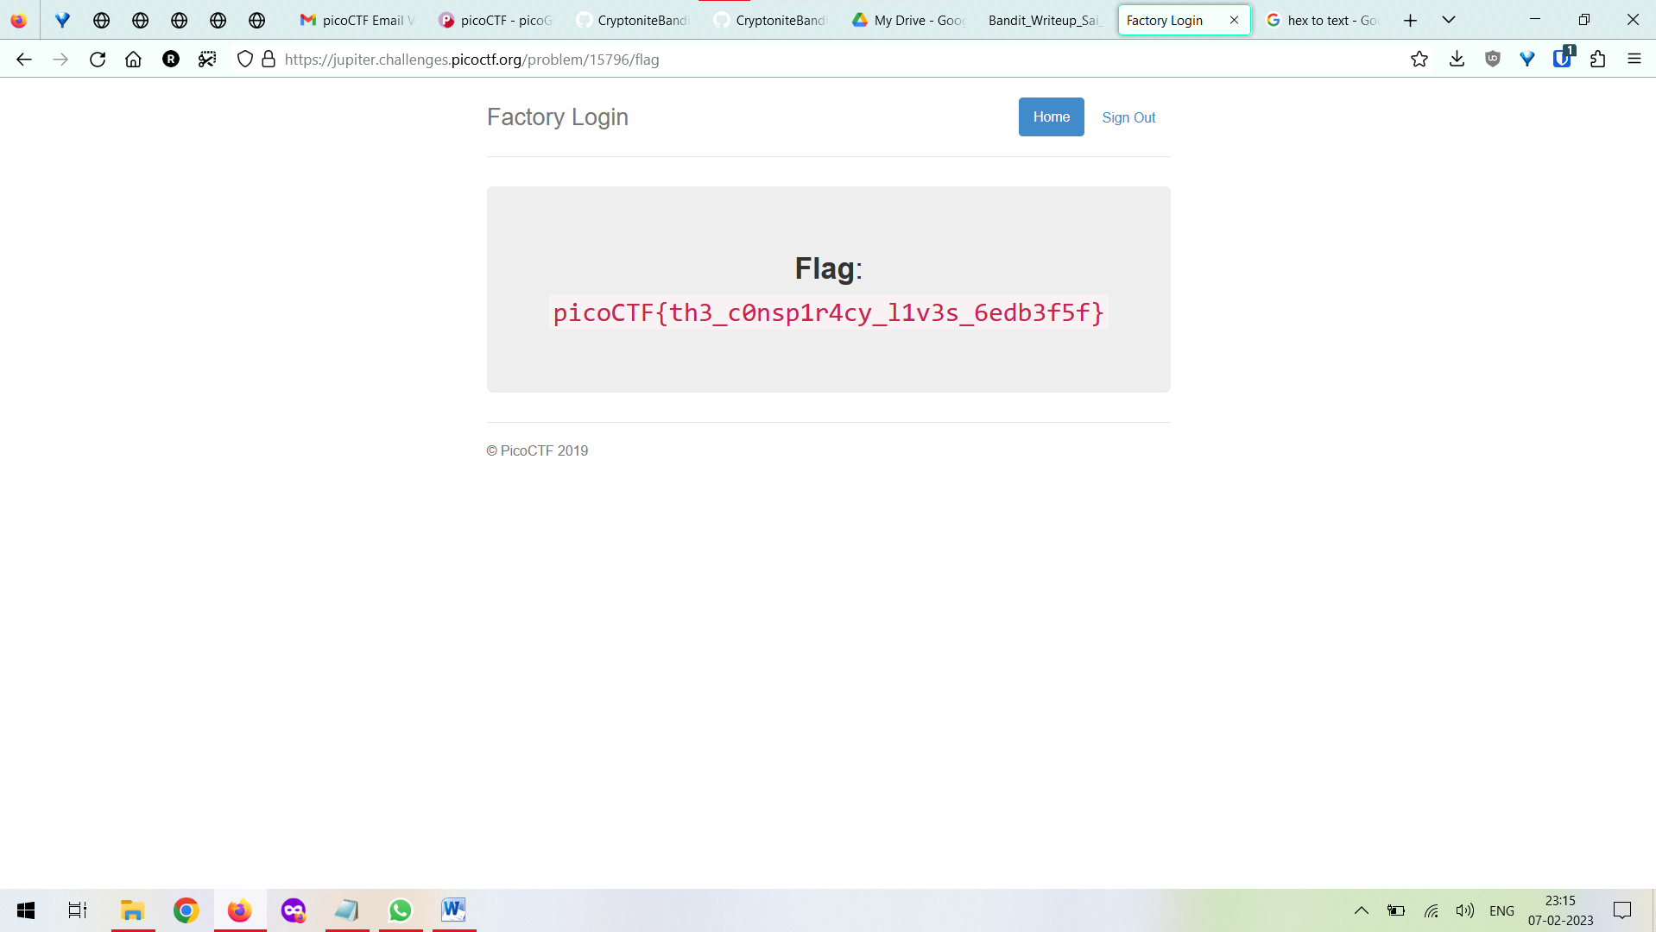

**New Caesar**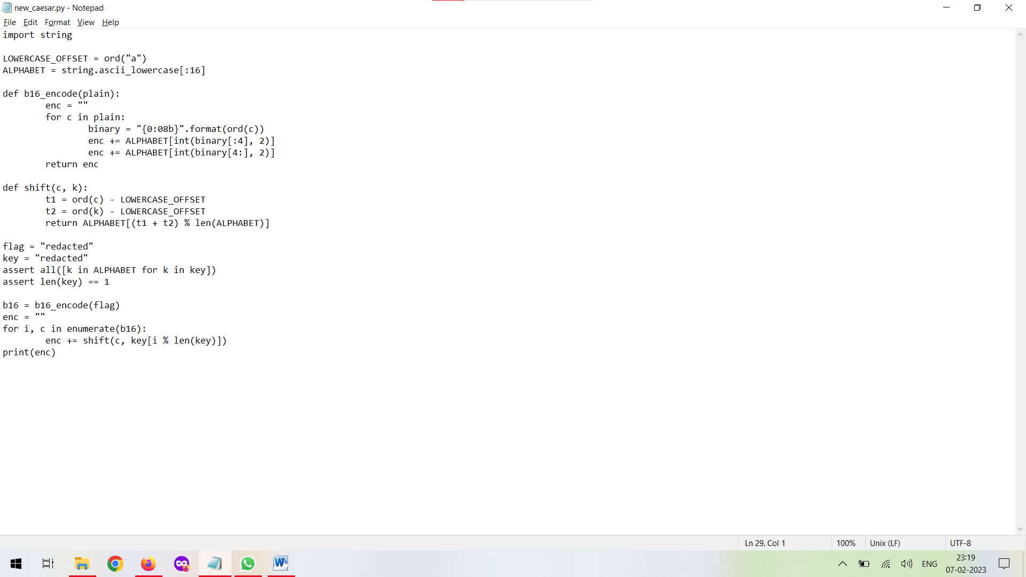  
If I can modify the code to undo whatever shifting it does or maybe work it out on paper I can figure out the key.  
  
1.The lowercase alphabet string is cut off to end at p (abcd….p)  
2. From the assert statements I got that the key is a single lowercase letter from the first 16 letters of the alphabet.  
3.The b16_encode function works by taking the ASCII of each character in the flag(which is its argument), converting to binary and padding to hit 8 bits, then splitting that into 2 parts, from the start to the 4th character and then from the 4th to the 8th character.  
4.That’s then treated as a base-2 number and converted to integer and then the corresponding letter from(abcd…p) is added to enc.  
5.In the for loop with the enumerate, we have a modulo w/ len(key), which is just 0 because for the assert to not throw an exception we’d need it to be 1. So the input for shift is basically shift(c, key[0]).

6. The enumerate function will give me each letter of b16 w/ the index, and the for loop uses both of those, but since we see that it’s just going to do shift(c,key[0]) we can get rid of i and alter the shift thing within the loop. After testing I saw that I got the same result.

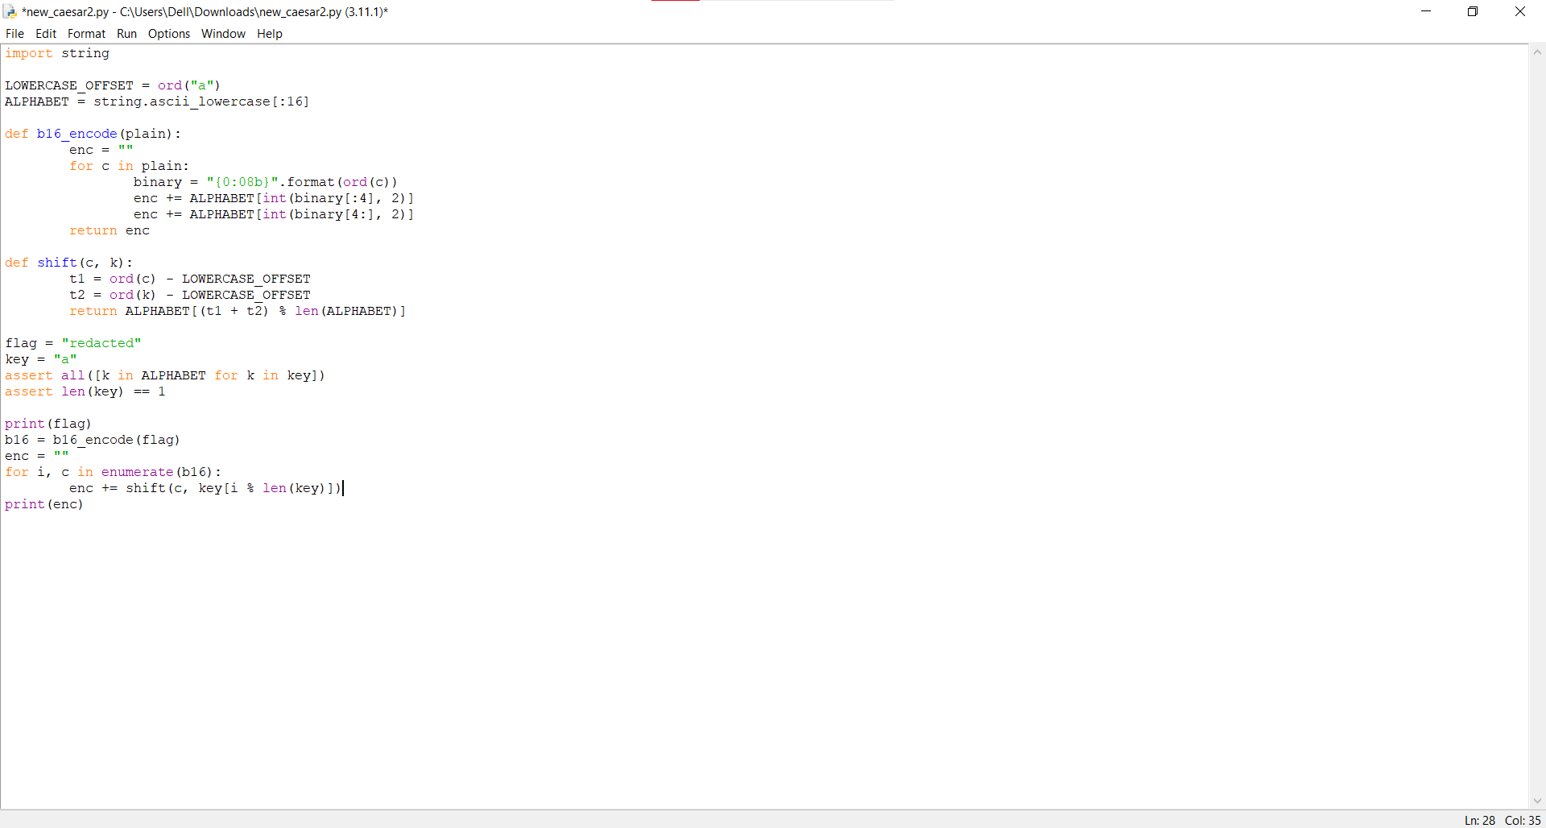

For every two letters in the output of b16_encode, there’s one letter in plain. So to reverse it, I’ll have to take every two letters of the encoded text, get their binary equivalent, combine those to get an 8 bit binary, then convert that to decimal and get the associated letter(chr ()).

After some trial and error, I also figured out how to get c provided k and the shifted letter.

picoctf{et_tu?_431db62c5618cd75f1d0b83832b67b46}

**tunn3l_v1s10n(!)**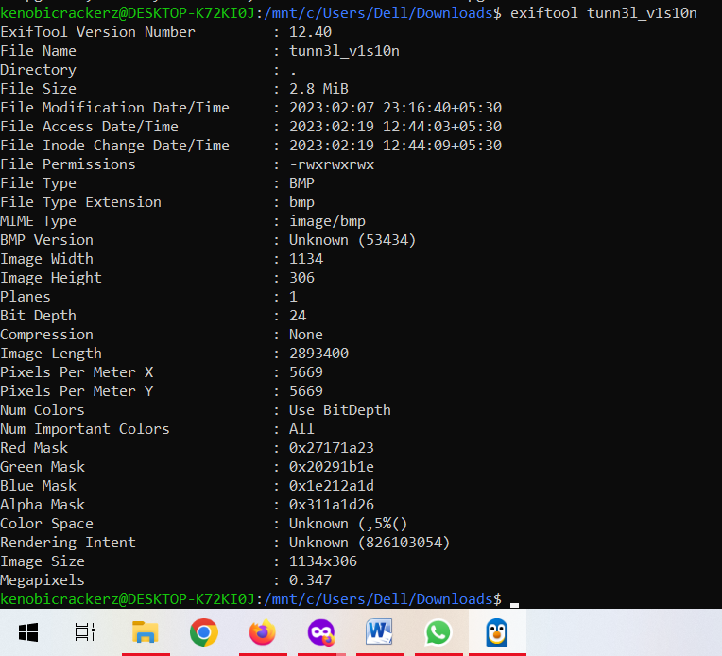

exiftool let me know it was a bitmap.

I then ran binwalk on the file, and got this 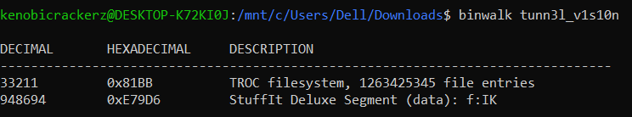

When I googled TROC filesystem, this was the first hit:  
<https://stackoverflow.com/questions/67403845/i-extracted-a-file-using-binwalk-i-discovered-it-has-a-troc-file-how-do-i-read>  
A reply said binwalk was useless so I opened it with ghex . I used [this link](https://www.ntfs.com/damaged-file-system-bmp.htm) and a couple others to learn more about dealing with bitmaps.



The commenter said data is *almost* correct, so I need to figure out if there’s some missing stuff.

Tunnel vision essentially means being focussed on/looking at a small part of something, so that’s what I figure this is about. However, at this point I’ve hit a brick wall, so I followed a [write-up](https://github.com/vivian-dai/PicoCTF2021-Writeup/blob/main/Forensics/tunn3l%20v1s10n/tunn3l%20v1s10n.md). The logic here is that the size doesn’t match what comes from calculating based on height and width, so we change the height of the image to get to the right size, and the flag’s displayed: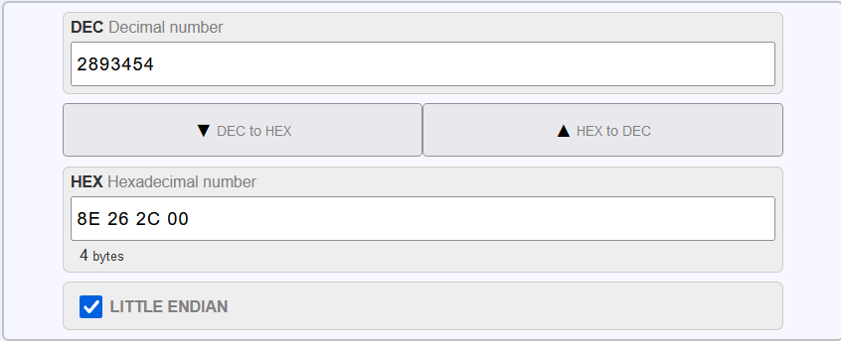 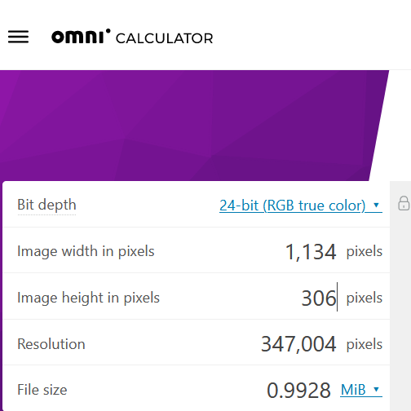

Picoctf(qu1t3_a_v13w_2020}

**MacroHard WeakEdge**I ran exiftools on the Forensics is Fun pptm, and it showed one hidden slide. I opened it, but it didn’t have the flag (☹)  
I then ran binwalk on the file.

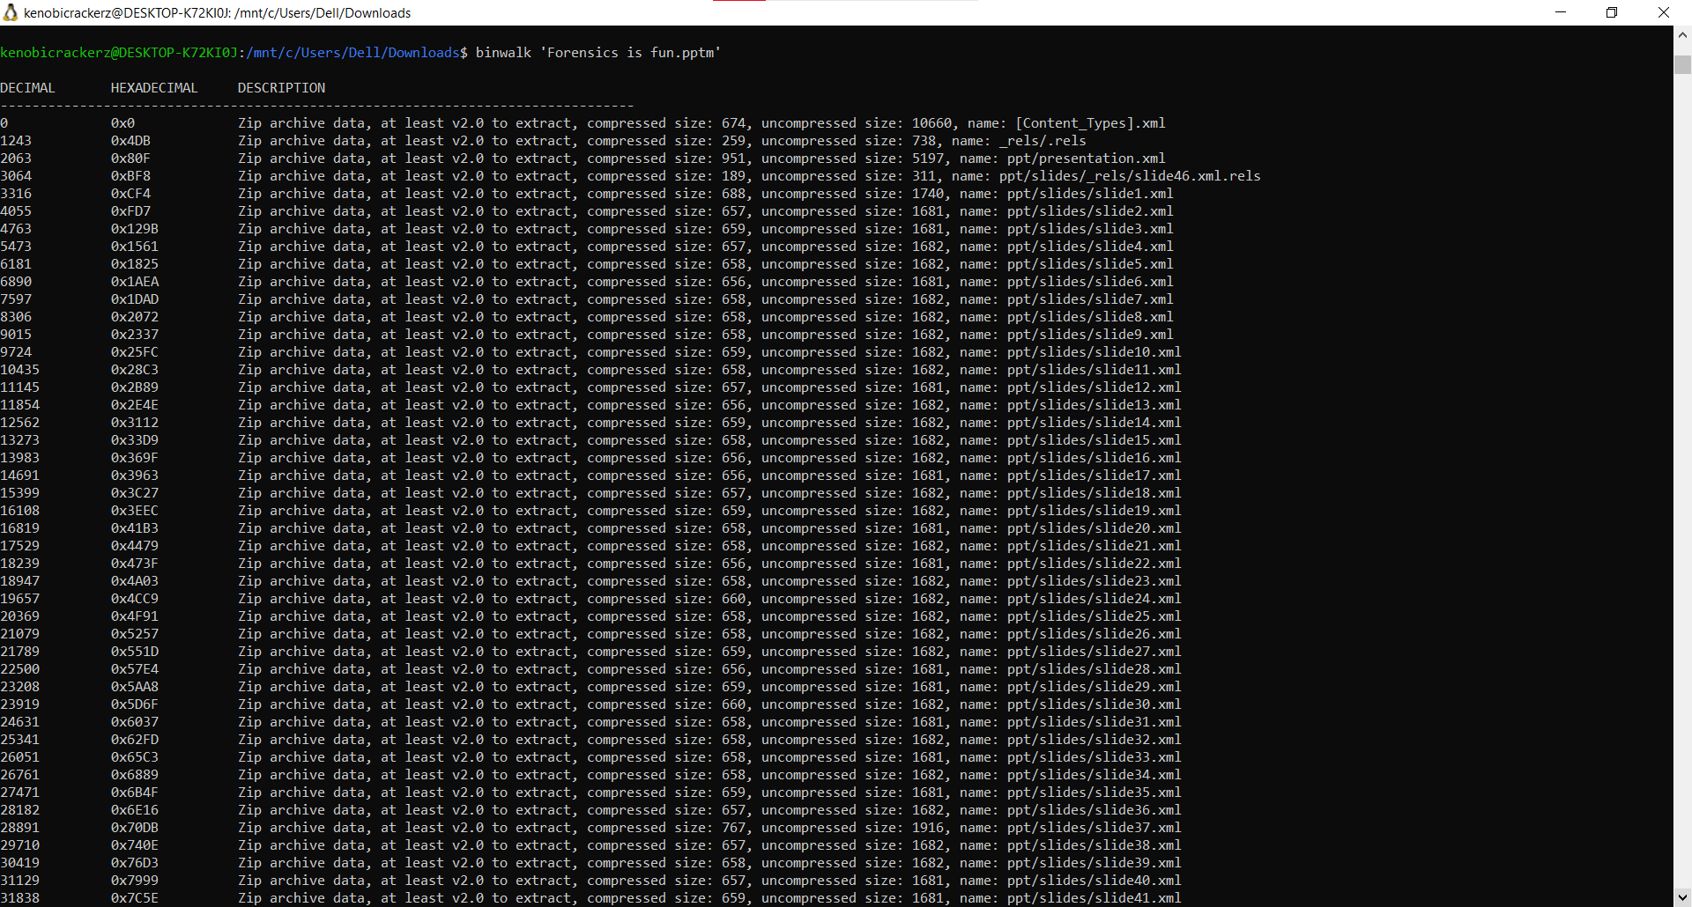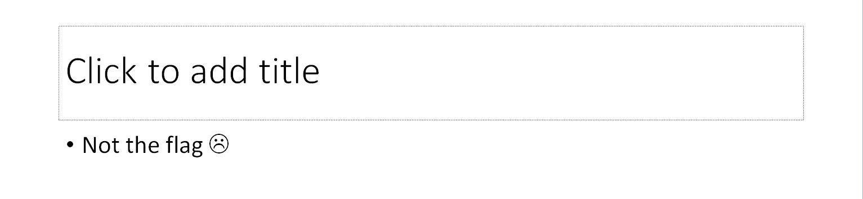



At the end I noticed a ‘hidden’ thing. Since it all showed up as Zip archive data, I changed the extension to .zip, and found the hidden file. I opened it with Notepad, and then ran the resulting text through a multi-decoder. It turned out to be b64, and I got the flag.

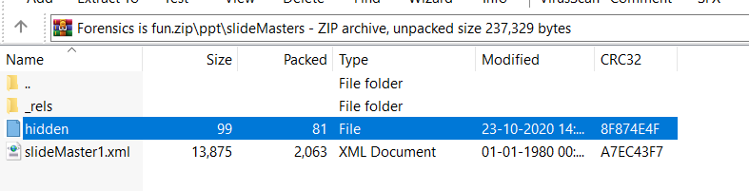 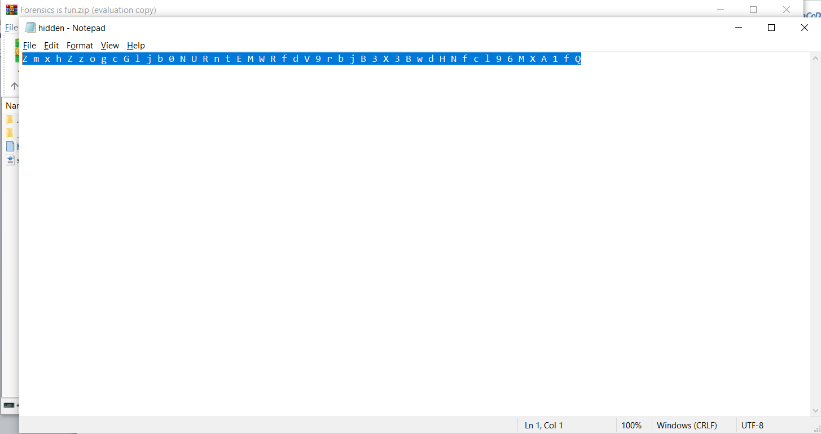

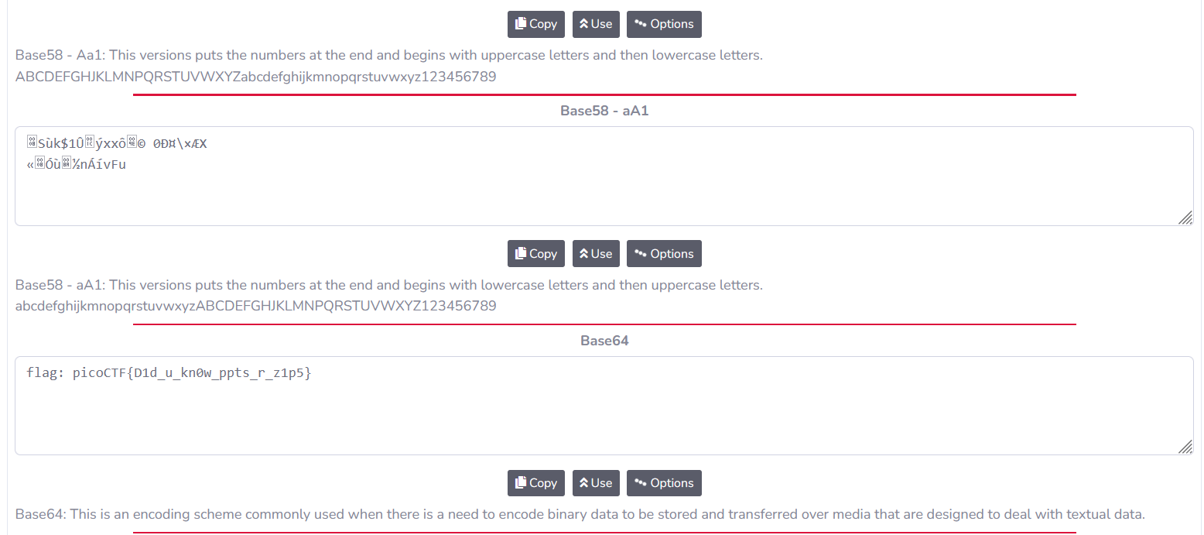

flag: picoCTF{D1d_u_kn0w_ppts_r_z1p5}

**miniRSA**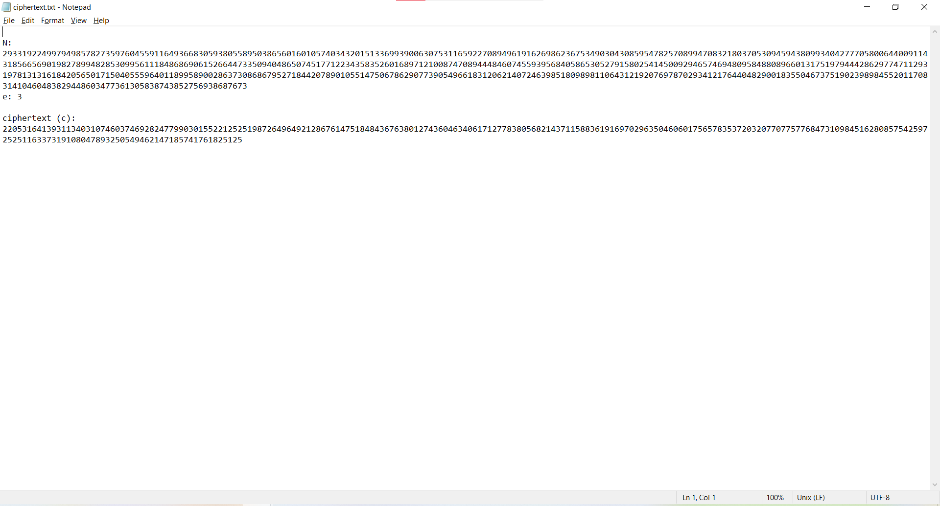Appended a .txt, opened in notepad,then used an online RSA decryptor with the given values for n,e, and c.  
  
picoCTF{n33d_a_lArg3r_e_606ce004}  
  
  
**wireshark doo doo..**Downloaded and ran wireshark on the file, Checked for which ones have text data (had to google “how to check for text within packets wireshark”)  
  
Then found this:  
Gur synt vf cvpbPGS{c33xno00_1_f33_h_qrnqorrs}  
  
Used a multi-decryptor and got this, it turned out to be a Caesar rot13  
picoCTF{p33kab00_1_s33_u_deadbeef}  
  
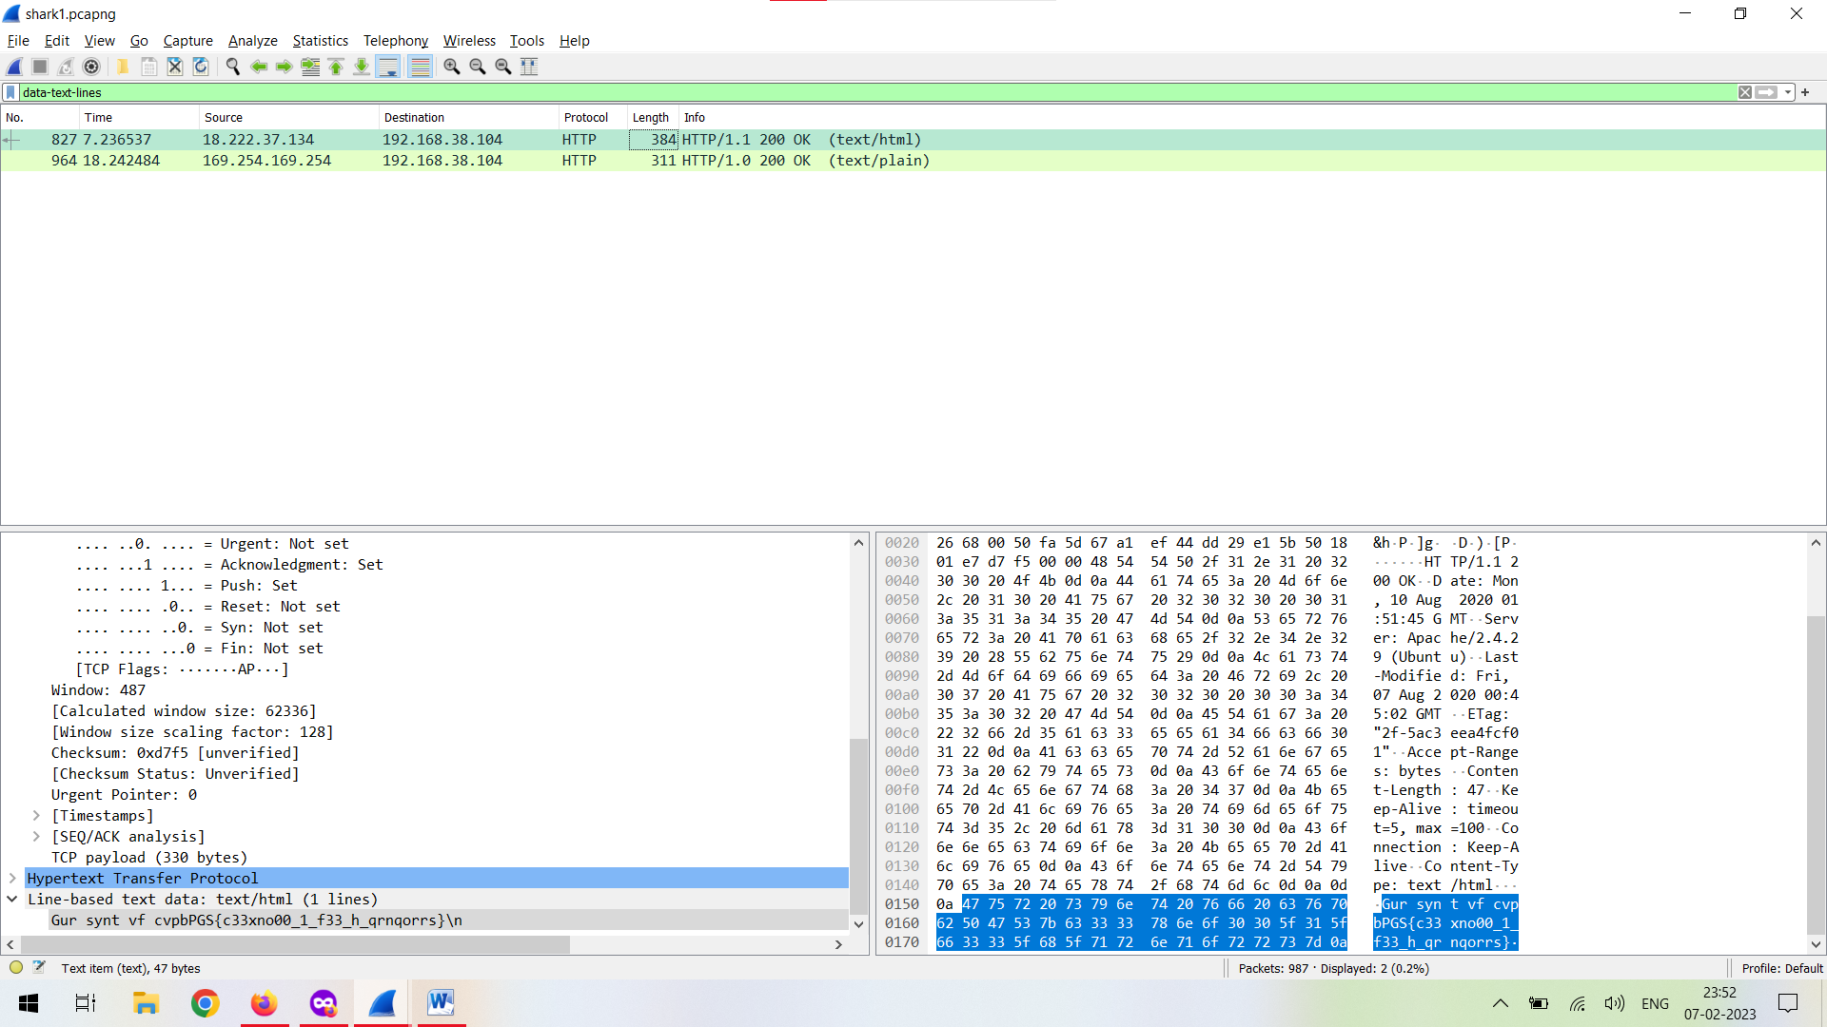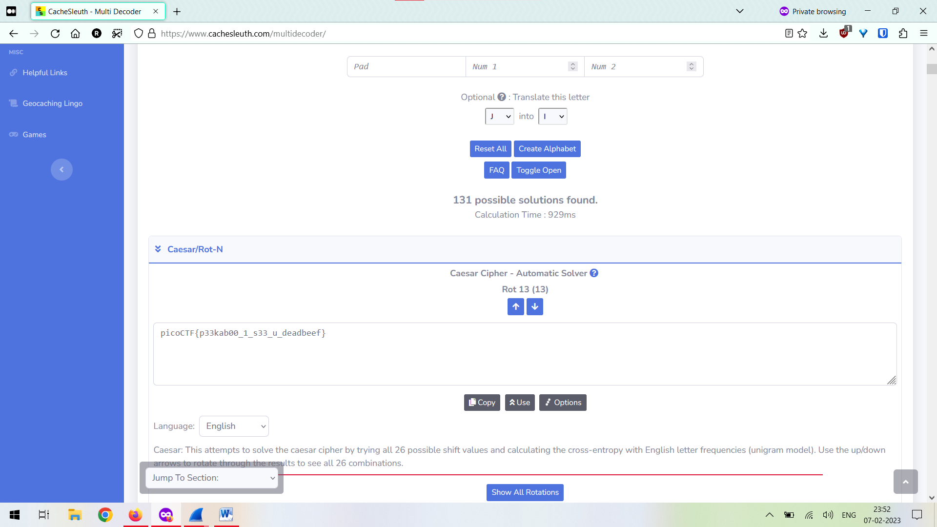  
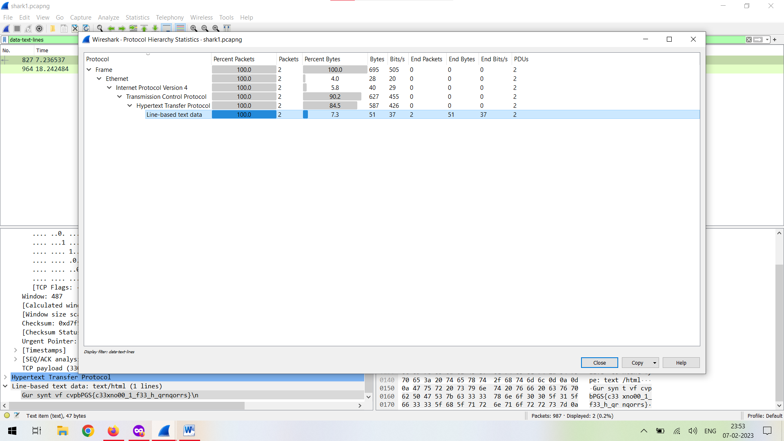

**Trivial Flag Transfer Protocol  
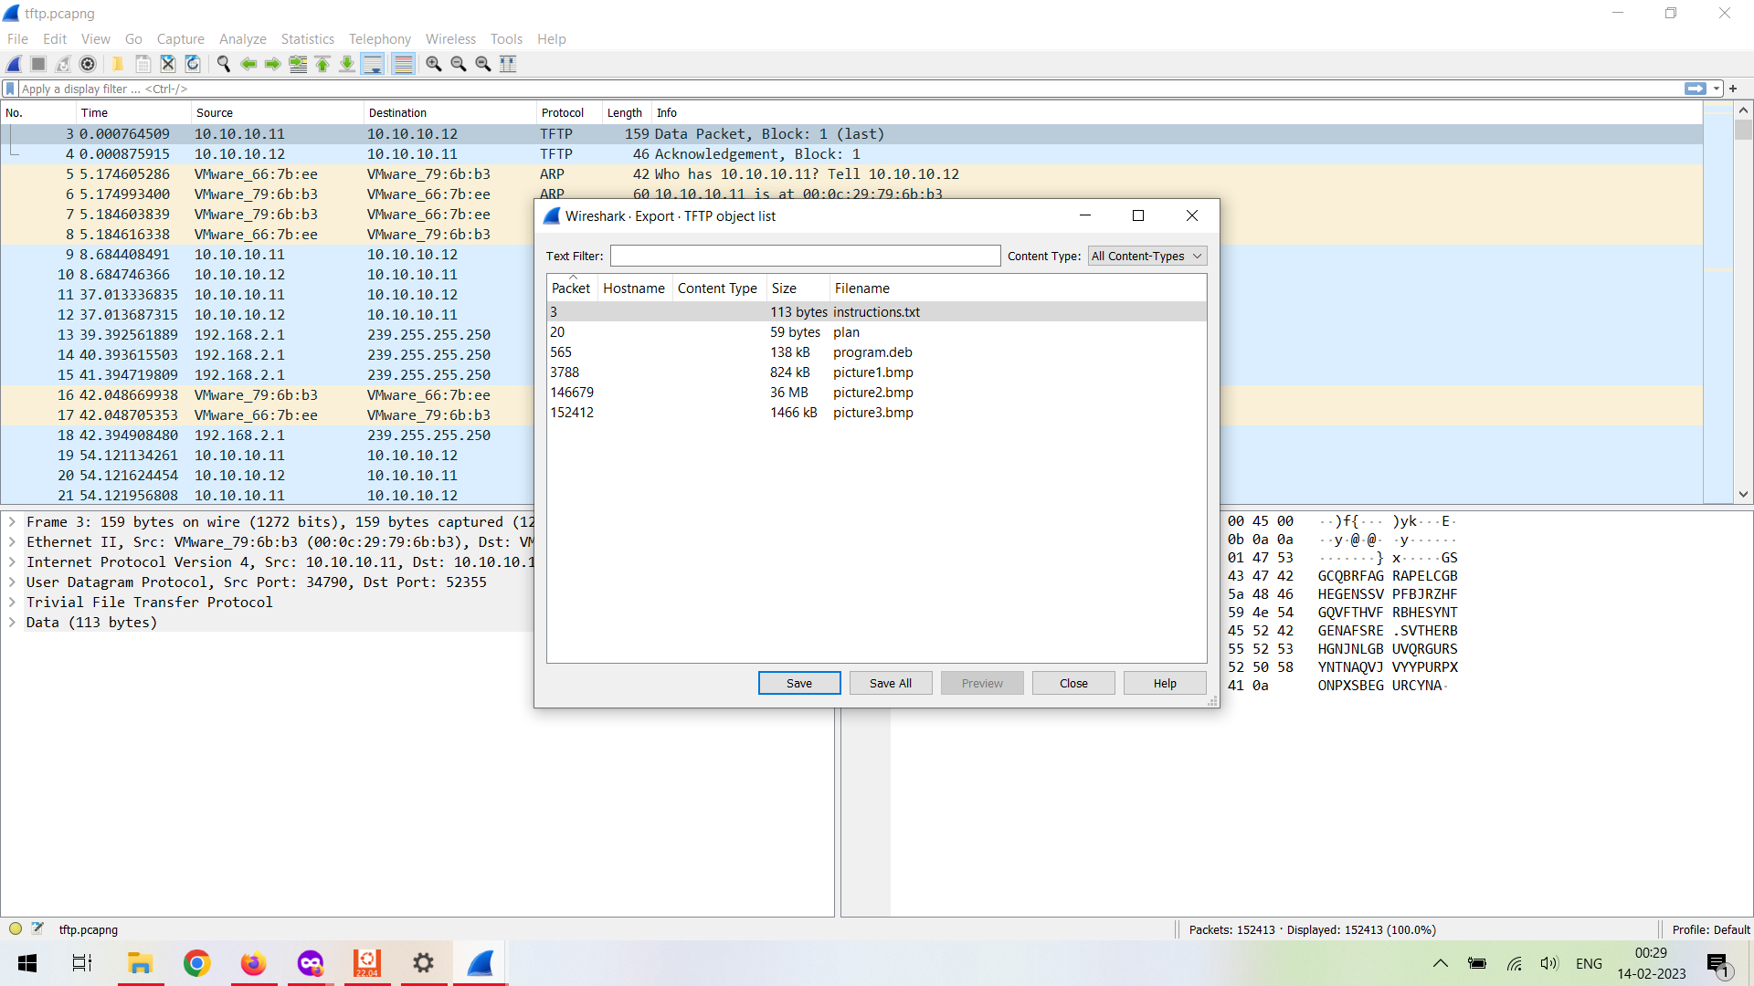**

Opened it in wireshark, then used File>Export Objects>TFTP  
Then saved all.  
  
I then went to instructions.txt, and had to convert plan to a .txt. I used an online multi-decryptor on both of them and got two messages. 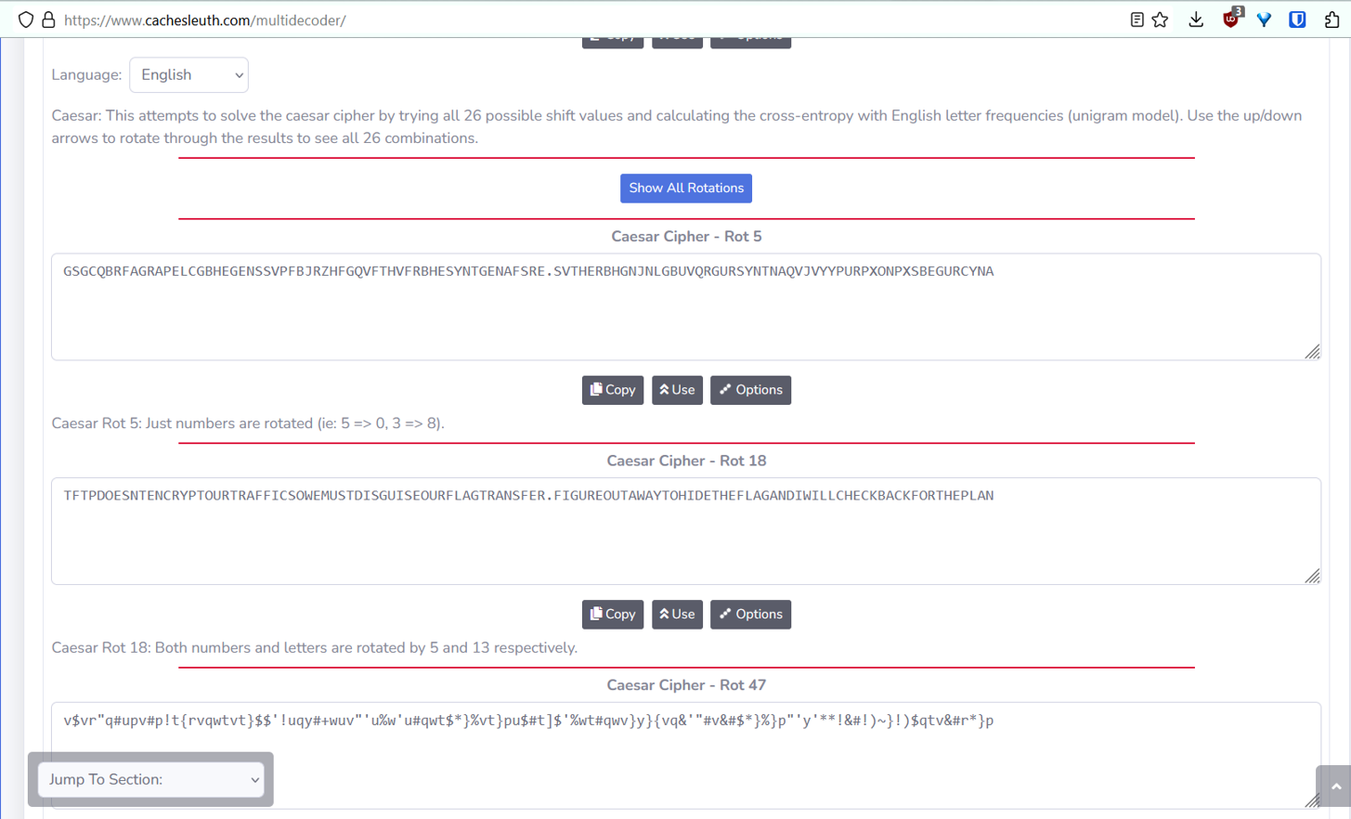  
  
After googling, I then executed the .deb w/ WSL and it turned out to be steghide.  
I then looked up how to use that properly and tried it with all 3 pictures. I also had to guess and check a couple of passwords.  
  
At this point, I googled the answer to check which image it was. It turned out to be picture3.  
Passphrase was: DUEDILIGENCE  
  
I then entered the passphrase and got the flag.  
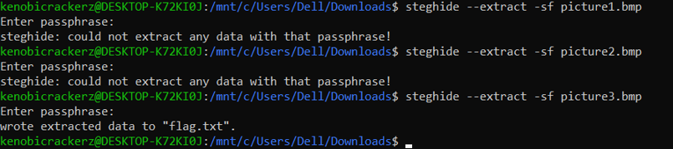

**Dachshund attacks**

I just had to enter the stuff in dcode.fr to get the flag.  
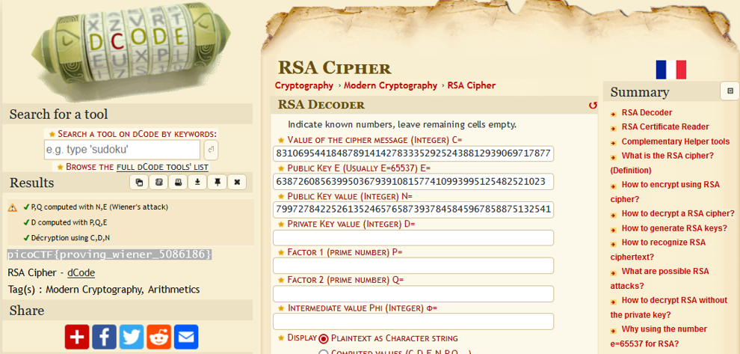

**Pixelated**

The hints link to a wiki article on visual cryptography. I looked through a few more blog posts and articles on visual cryptography, but couldn’t figure out how to code a solution myself. I instead used stegsolve mentioned in the [bi0s wiki](https://wiki.bi0s.in/steganography/stegsolve/).



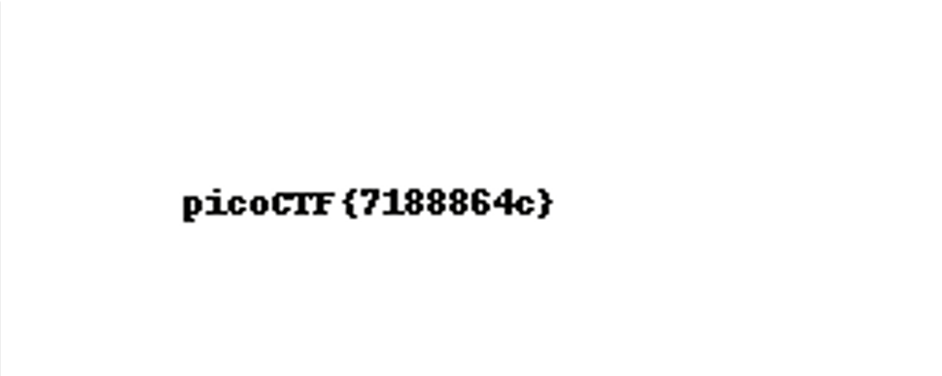 

picoctf{7188864c}

**picobrowser**I googled how sites figure out which browser you’re using, and came across the concept of a user-agent.

<https://www.makeuseof.com/tag/trick-websites-changing-user-agent-chrome/>

Since the firefox method was complicated, I opened it in chrome, and changed the user agent to picobrowser.

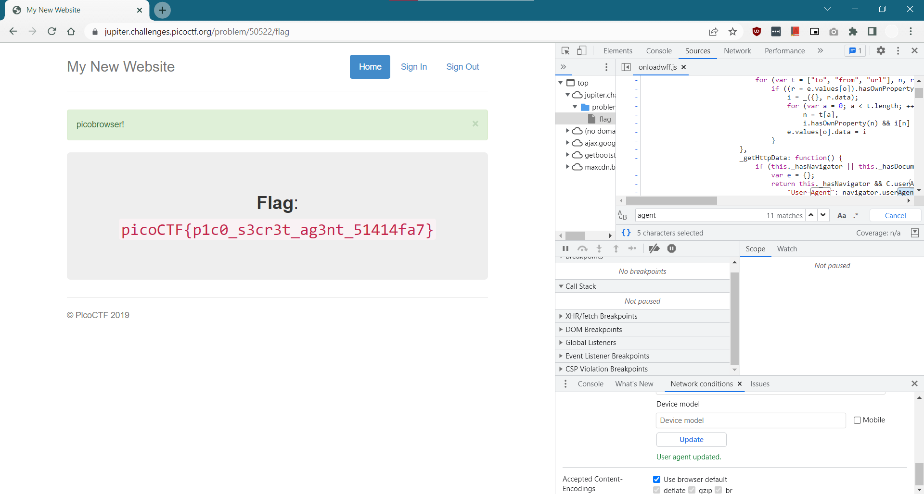  
picoCTF{p1c0_s3cr3t_ag3nt_51414fa7}

**Notepad(!)**

Going through the stuff in the source, I noticed that / and _ are not allowed.

I tried typing those into notepad and got the bad content error.

Typing “valid” stuff would cause the site to redirect me to site/(<entered content> + a string of text appended to it)  
This means I need to figure out the path to the flag.

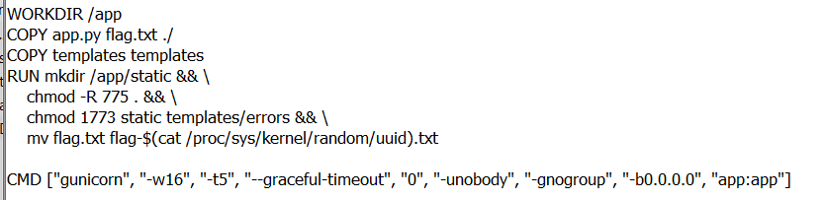

The dockerfile has mentions of flag.txt, so we need to work from there.

I couldn’t figure out where to go beyond this point, and so I just followed completely the solution given at <https://github.com/Dvd848/CTFs/blob/master/2021_picoCTF_redpwn/notepad.md>.

picoCTF{styl1ng_susp1c10usly_s1m1l4r_t0_p4steb1n}

**Web Gauntlet:**I learnt about SQL injections from https://vm-thijs.ewi.utwente.nl/ctf/sql

In the challenge, the goal is to login as admin, and the password doesn’t matter. This means we need to terminate the SQL select statement after the user=admin part, and the challenge is to do this while there’s filters in place.

I followed <https://www.hackingarticles.in/bypass-filter-sql-injection-manually/> and https://portswigger.net/support/sql-injection-bypassing-common-filters/ in completing this one.

Round 1:  
*or* is filtered, so we cannot use that.  
I tried **admin’- -** as my filter, and it worked.

Round 2:  
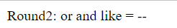

I can’t use the same methods as round1.

Here, I tried **admin’/\*** and it worked

Round 3:

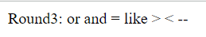

Round2 option did not work for some reason, so I tried ; which the blogpost above mentioned as a terminator.

**admin’;** worked.

Round 4:  
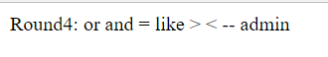

I tried a few options like ad/**/min with everything else the same as in Round 2/3 but they didn’t work. I thought of using UNION but those need us to be sure that both queries give the same number of output entries.

It took me some time to work it out, but **adm’||’in’/\*** worked.

Round 5:  
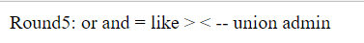

UNION will be filtered out, but since we haven’t used it anywhere in all our queries we can use the prev. query again.

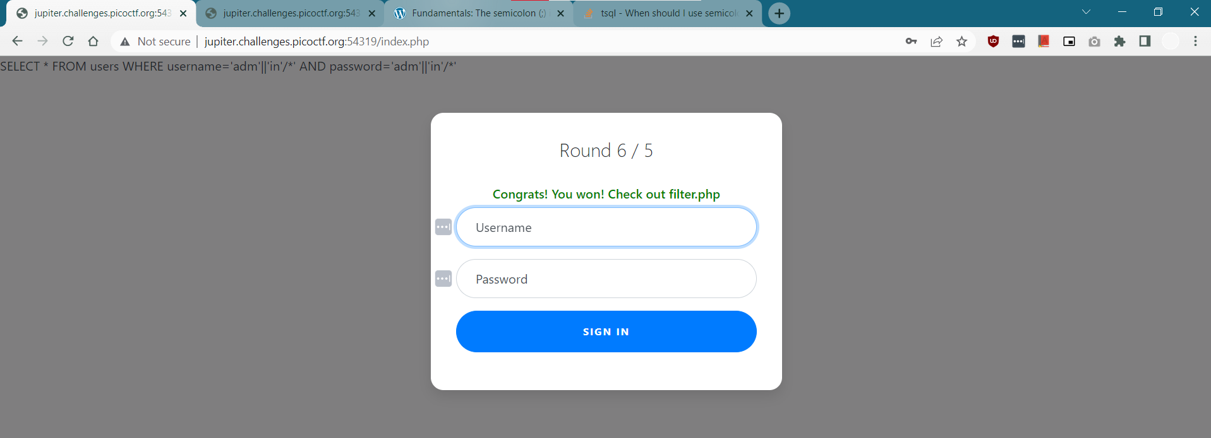 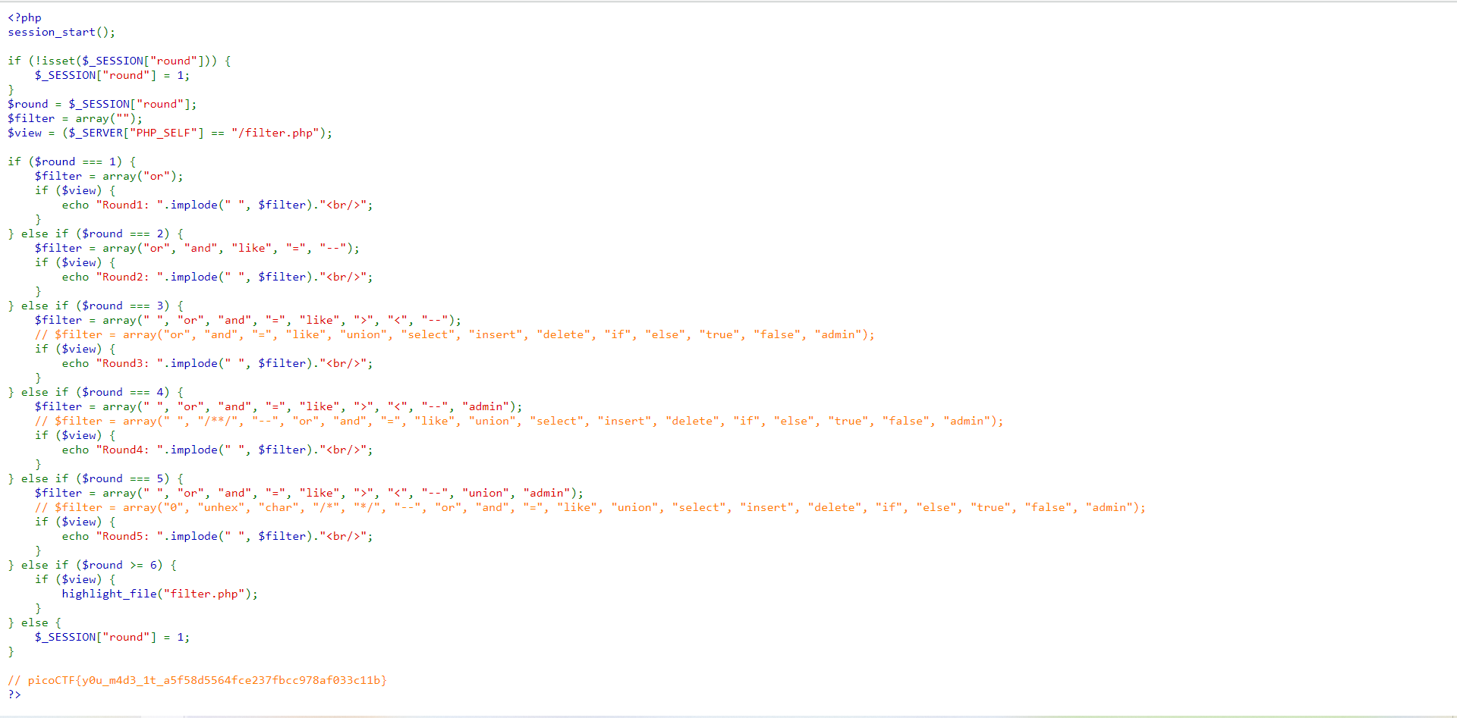 picoCTF{y0u_m4d3_1t_a5f58d5564fce237fbcc978af033c11b}

**Shop**

In the shop program, I saw that we have coins, but not enough for a flag. I tried a few options and then from the hint for edge cases I decided I’d try a negative number, and my coin count increased.

I then purchased the flag, and ran that through a multi-decoder. It was ASCII.

picoCTF{b4d_brogrammer_b8d7271f}



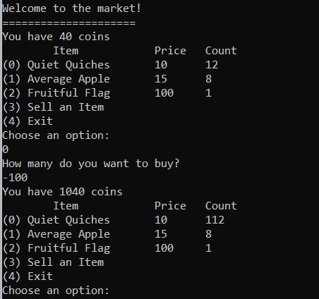

**Hurry Up!Wait! (!)**

I used file on source, and it turned out to be an ELF, which is the linux equivalent of a .exe from what I’ve read online.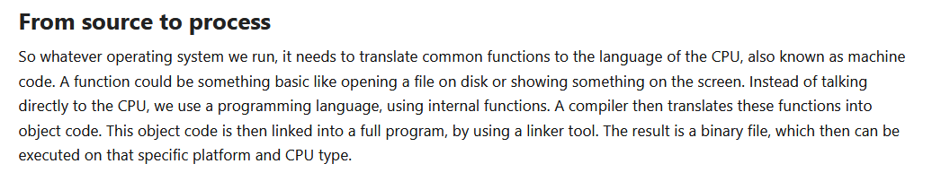

So the ELF is the compiled C code, and I need a decompiler to get the source code.

<https://stackoverflow.com/questions/17247505/how-to-convert-an-elf-executable-to-c-code-the-generated-c-code-need-not-be-hum>

<https://stackoverflow.com/questions/47097172/decompile-elf-on-windows>

I downloaded and ran ghidra. After this part, I had to go through a writeup to figure out what to do.

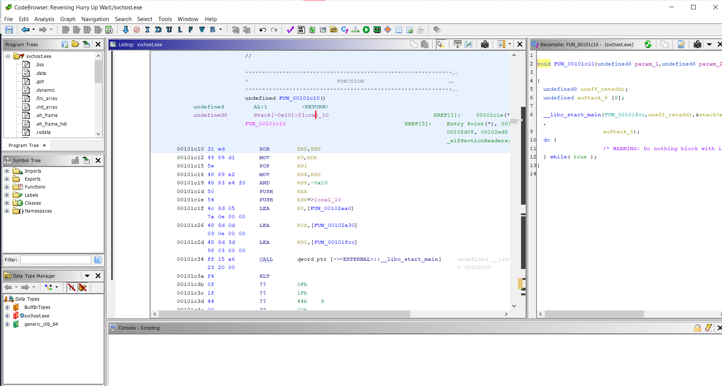 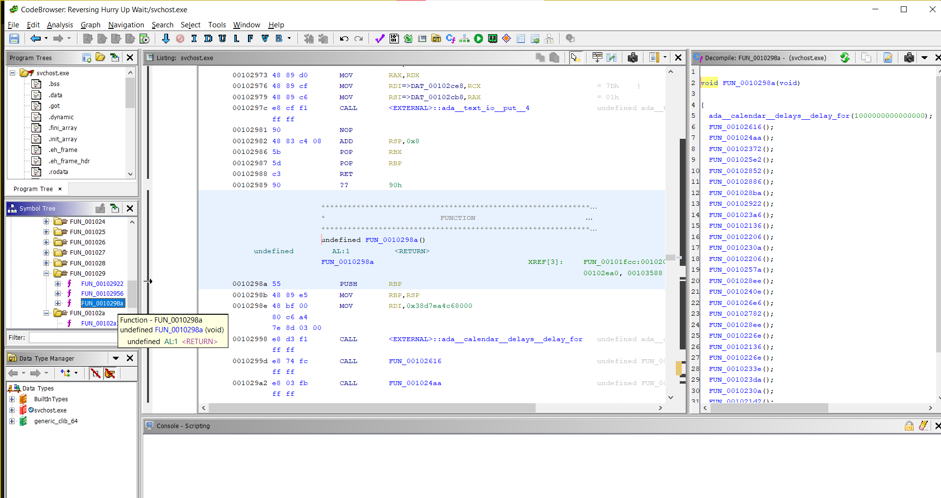  
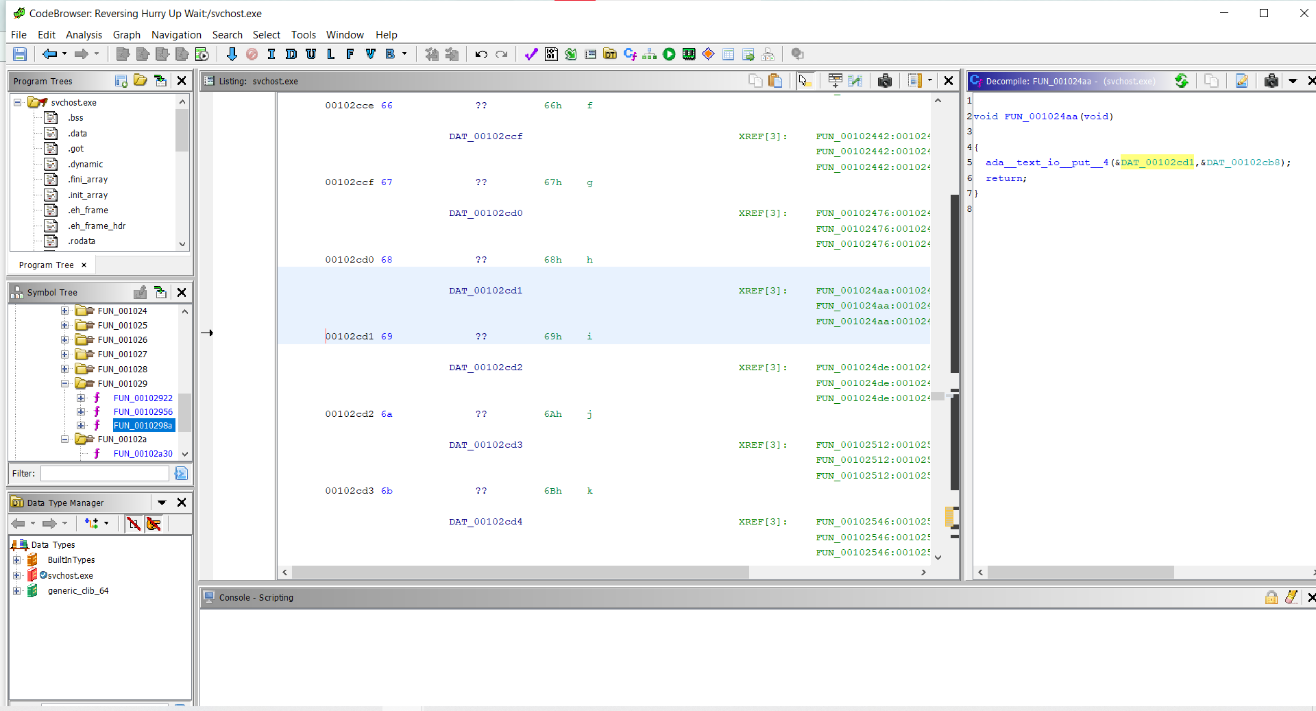

picoCTF{d15a5m_ftw_717bea4}

**Vault-Door 1**

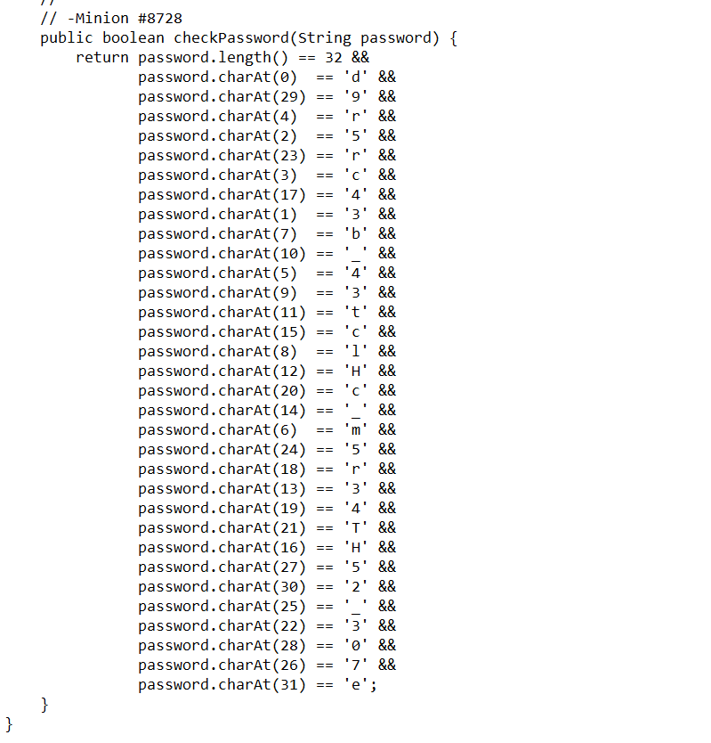

I just manually typed out the password.

picoCTF{d35cr4mbl3_tH3_cH4r4cT3r5_75092e}

**Vault-Door 3**

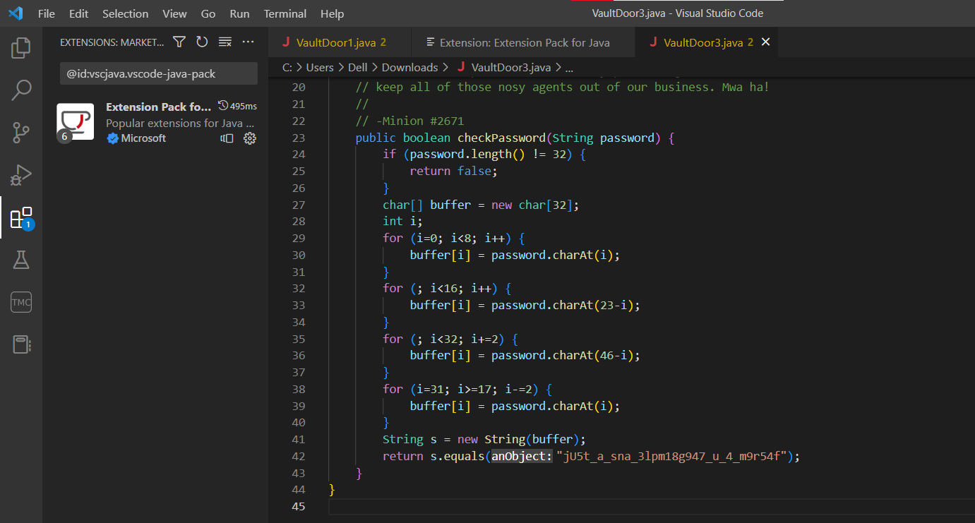

So the password after getting scrambled up gives the jU5t_a_sna_3lpm18g947_u_4_m9r54f text.

I manually wrote down what each part of the password the text equated to.(I did also work out the loop but in reverse later myself, and in hindsight it might’ve been faster.)

picoCTF{jU5t_a_s1mpl3_an4gr4m_4_u_79958f}

**Vault-Door 4**

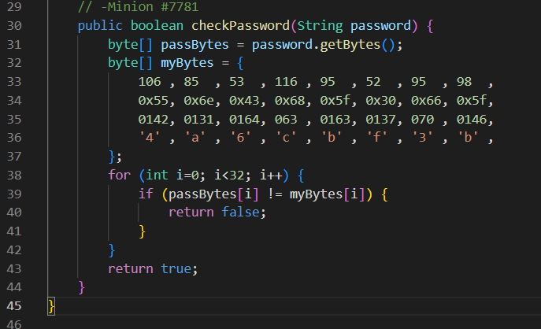 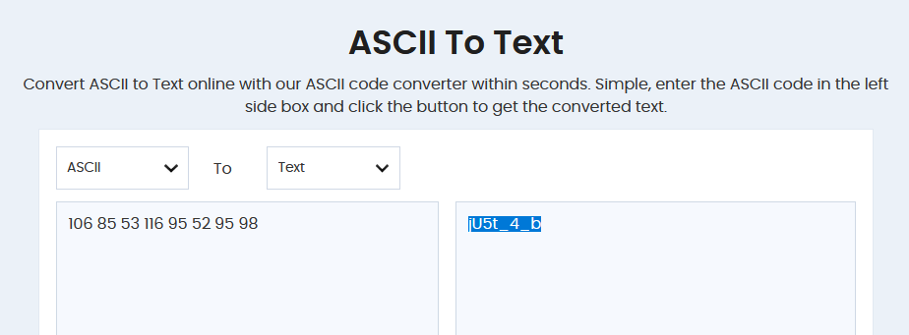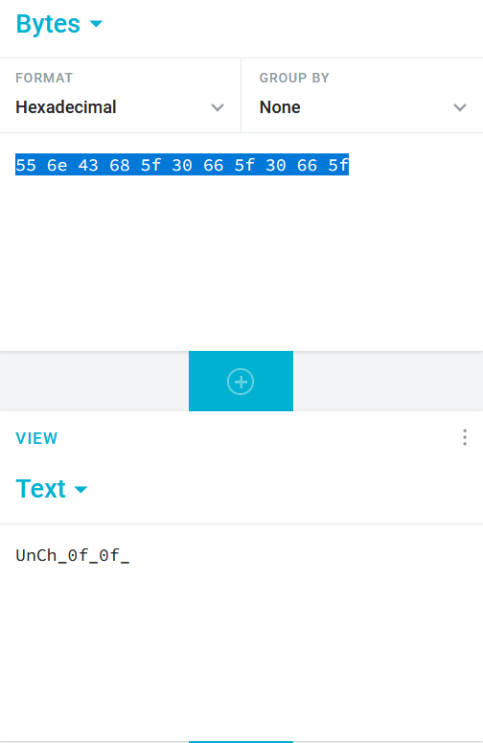

So the password has to match 1-to-1 with myBytes, and myBytes has ASCII hex and octal encoding peppered in along with all the characters at the end.

picoCTF{jU5t_4_bUnCh_0f_ bYt3s_8f4a6cbf3b}

picoCTF{jU5t_4_bUnCh_0f_bYt3s_8f4a6cbf3b}

**Vault-Door 5**

This one builds up on the prev. challenge and involves a URL encoder.

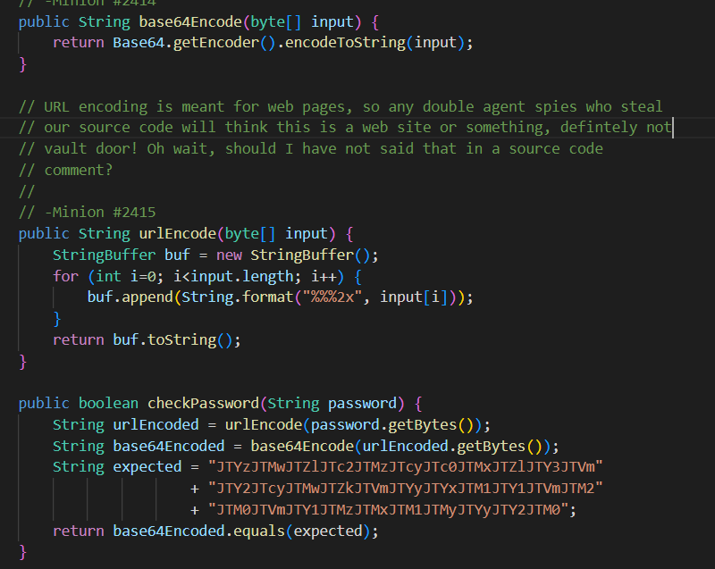

So takes password, performs url encoding then b64 encoding, and to return true we need to get the end result equal to the given string.

We can work backwards and take the given string, pass it through a b64 decoder, then a url decoder, and get the password.

+ is the concatenation operator in Java, so we need to combine all these strings.

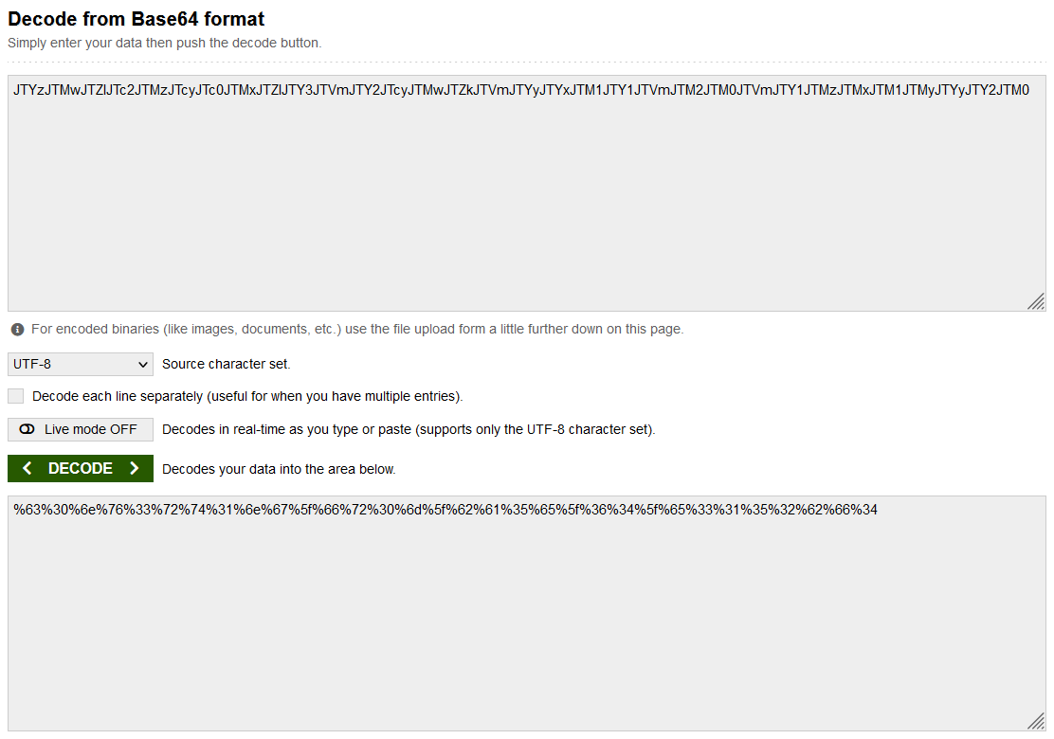 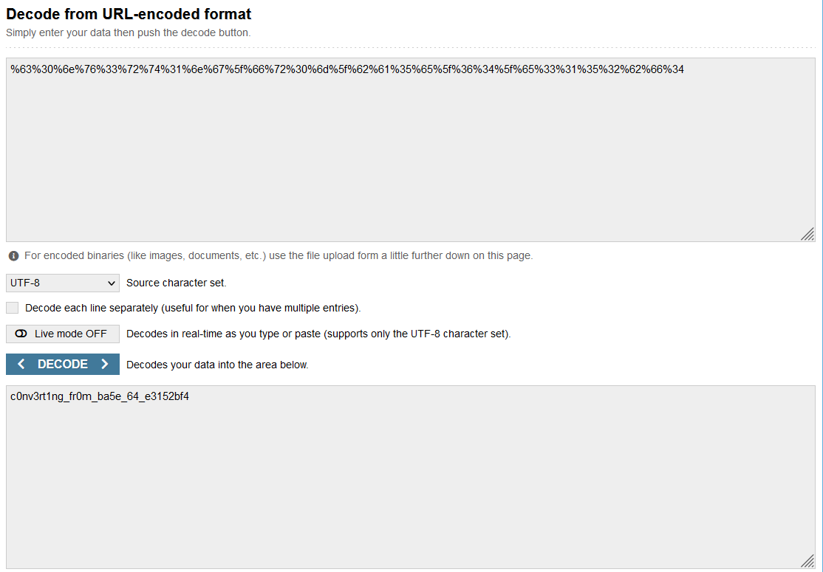

picoCTF{c0nv3rt1ng_fr0m_ba5e_64_e3152bf4}

**Vault-Door 6**

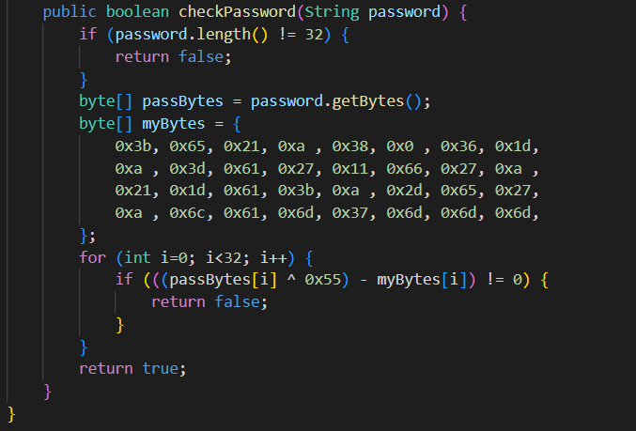

So to return true means to check if the character at index ***i*** in myBytes is the same as the character at the same index XOR’d with 0x55 in password.

<https://stackoverflow.com/questions/14279866/what-is-inverse-function-to-xor>

From this, we can see that we can apply XOR 0x55 with myBytes[i] to get passBytes[i].

myBytes[i]=passBytes[i]^0x55

passBytes[i]=myBytes[i]^0x55

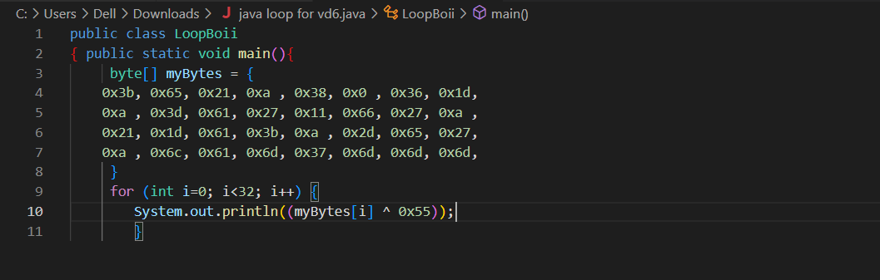

I tried using online decoders but it was too tedious, so I just printed it out in java.

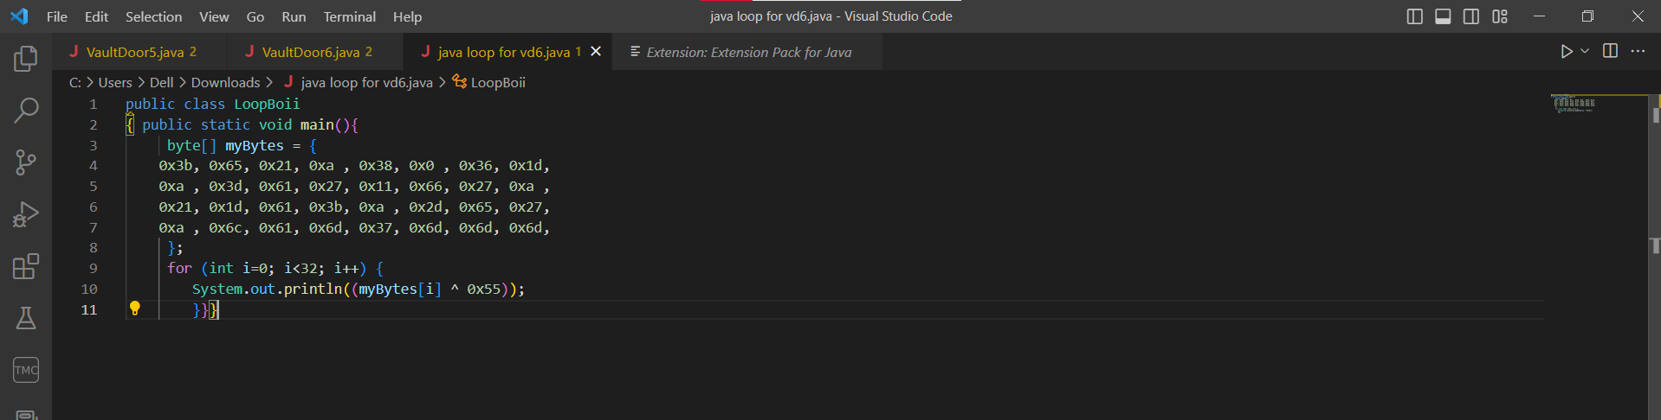

This didn’t give me the output I wanted, so I googled:  
<https://stackoverflow.com/questions/13851743/how-to-format-numbers-to-a-hex-strings>  
I then used this tutorial and modified my code, and ran it to get the numbers, which I then collectively ran through a hex decoder. I tried different widths, and width 4 gave me each one on a separate line.

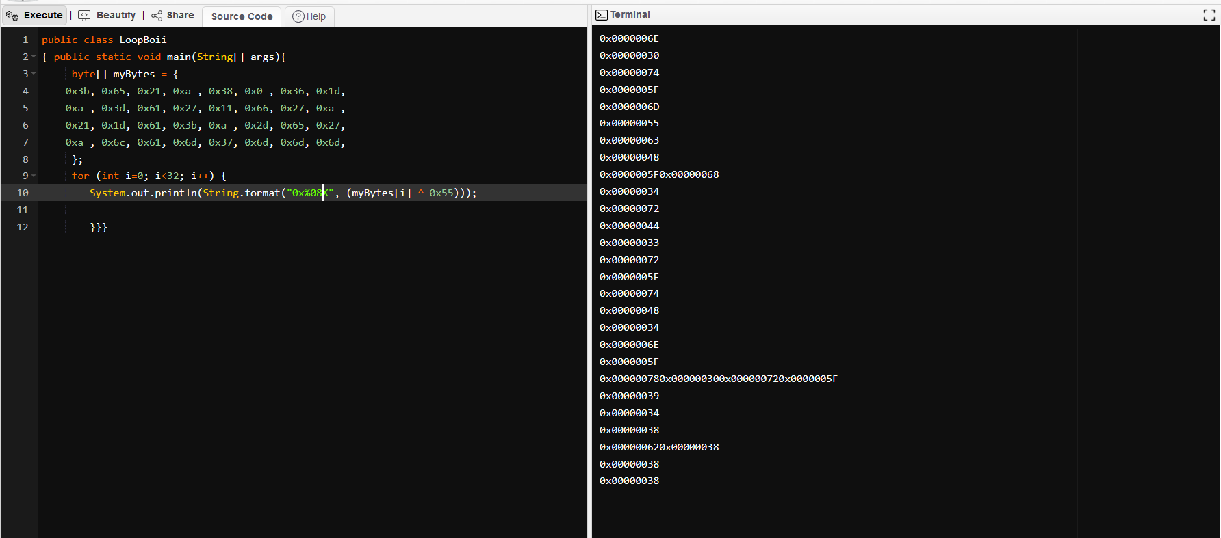 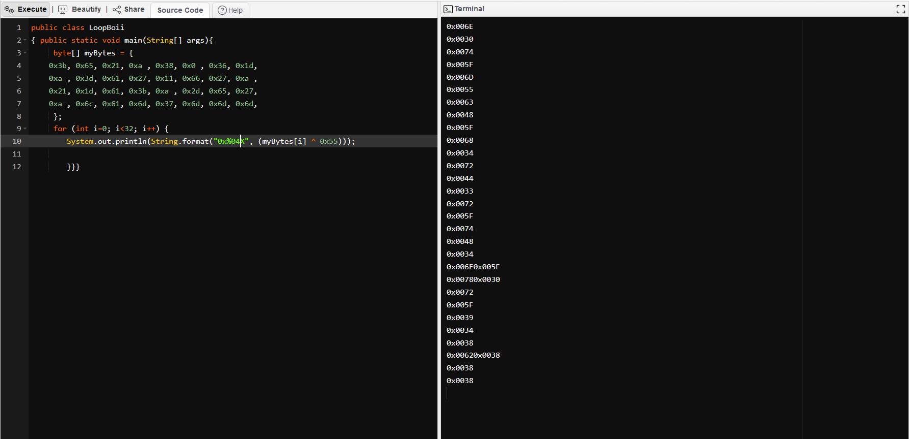

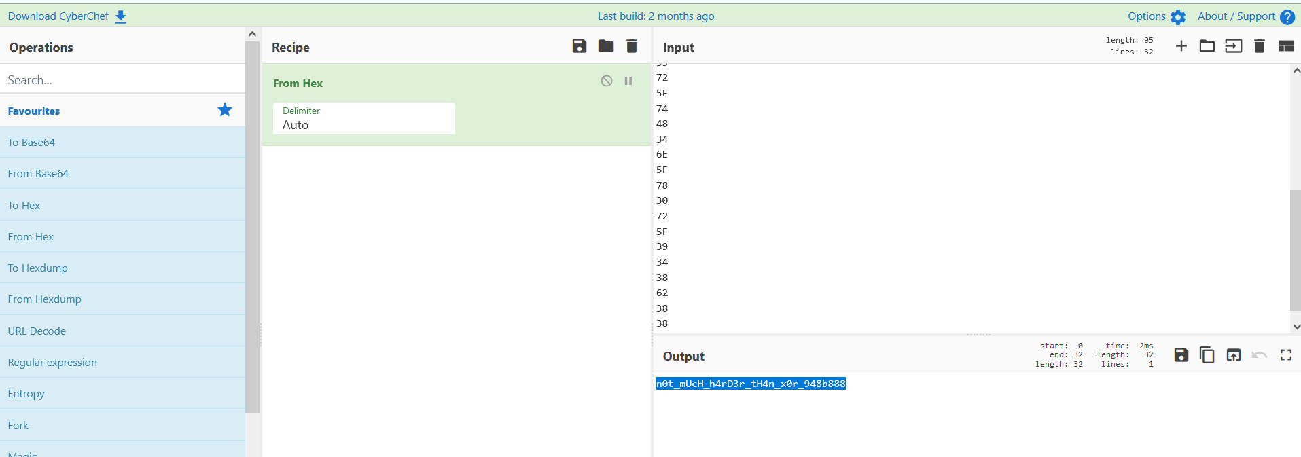

picoCTF{ n0t_mUcH_h4rD3r_tH4n_x0r_948b888}

**Vault-Door 7(!)**

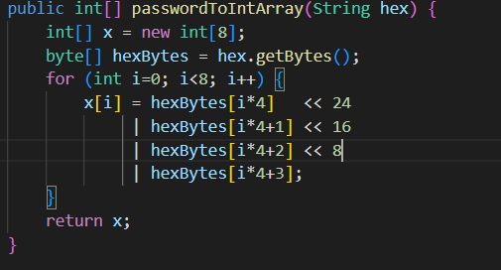

From this part, we can see that bitwise OR operation’s being done. We can also see that they’re different bitwise shifts.

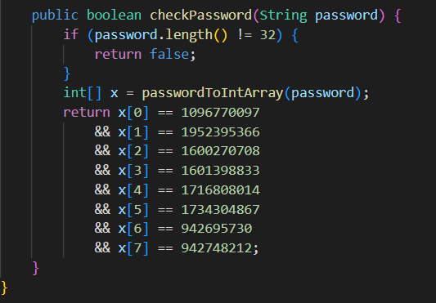

From the explanation provided in the comments on the program, we can see that each integer has to be converted to binary, then the binary has to be split into 4 groups of 8 bits, which when each converted into hex give us 4 characters.

<https://stackoverflow.com/questions/62974087/how-do-i-inverse-this-bitwise-operation>

<https://stackoverflow.com/questions/5330520/what-is-the-reverse-operation-of-bitwise-and>

From these two posts I could see that there was no way to reverse the OR(|) operation, but I still wanted to try the part before the OR and see what I’d get.

<https://www.javatpoint.com/java-decimal-to-binary>

I used this to convert the elements of the array to binary strings, then convert those into the ASCII.

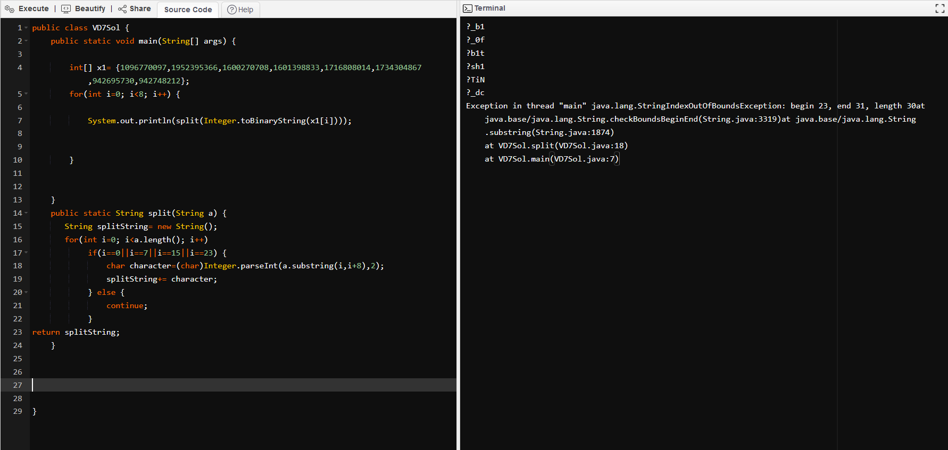

I couldn’t figure out how to implement the logic in code, so I ended up looking for a script in a writeup.

picoCTF{A_b1t_0f_b1t_sh1fTiNg_dc80e28124}

**Surfing the Waves(!)**

I opened the file in Audacity and tried to see if there was anything in the spectrogram.

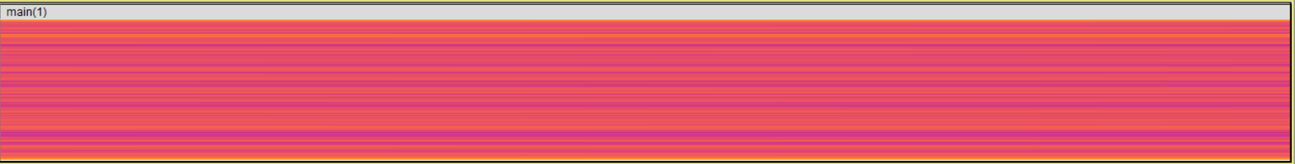

I found nothing, but on switching back to waveform when ‘zoomed in’ I noticed a periodic structure.

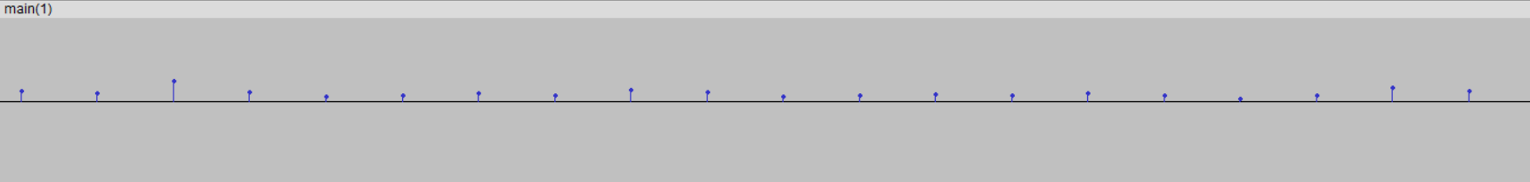

First guess is we have to take the values and put them through a multi-decoder, but I have been unable to find an option to check the exact y-axis readings for each point.

<https://forum.audacityteam.org/viewtopic.php?t=83000>

I used this to figure out how to get the y-axis readings.

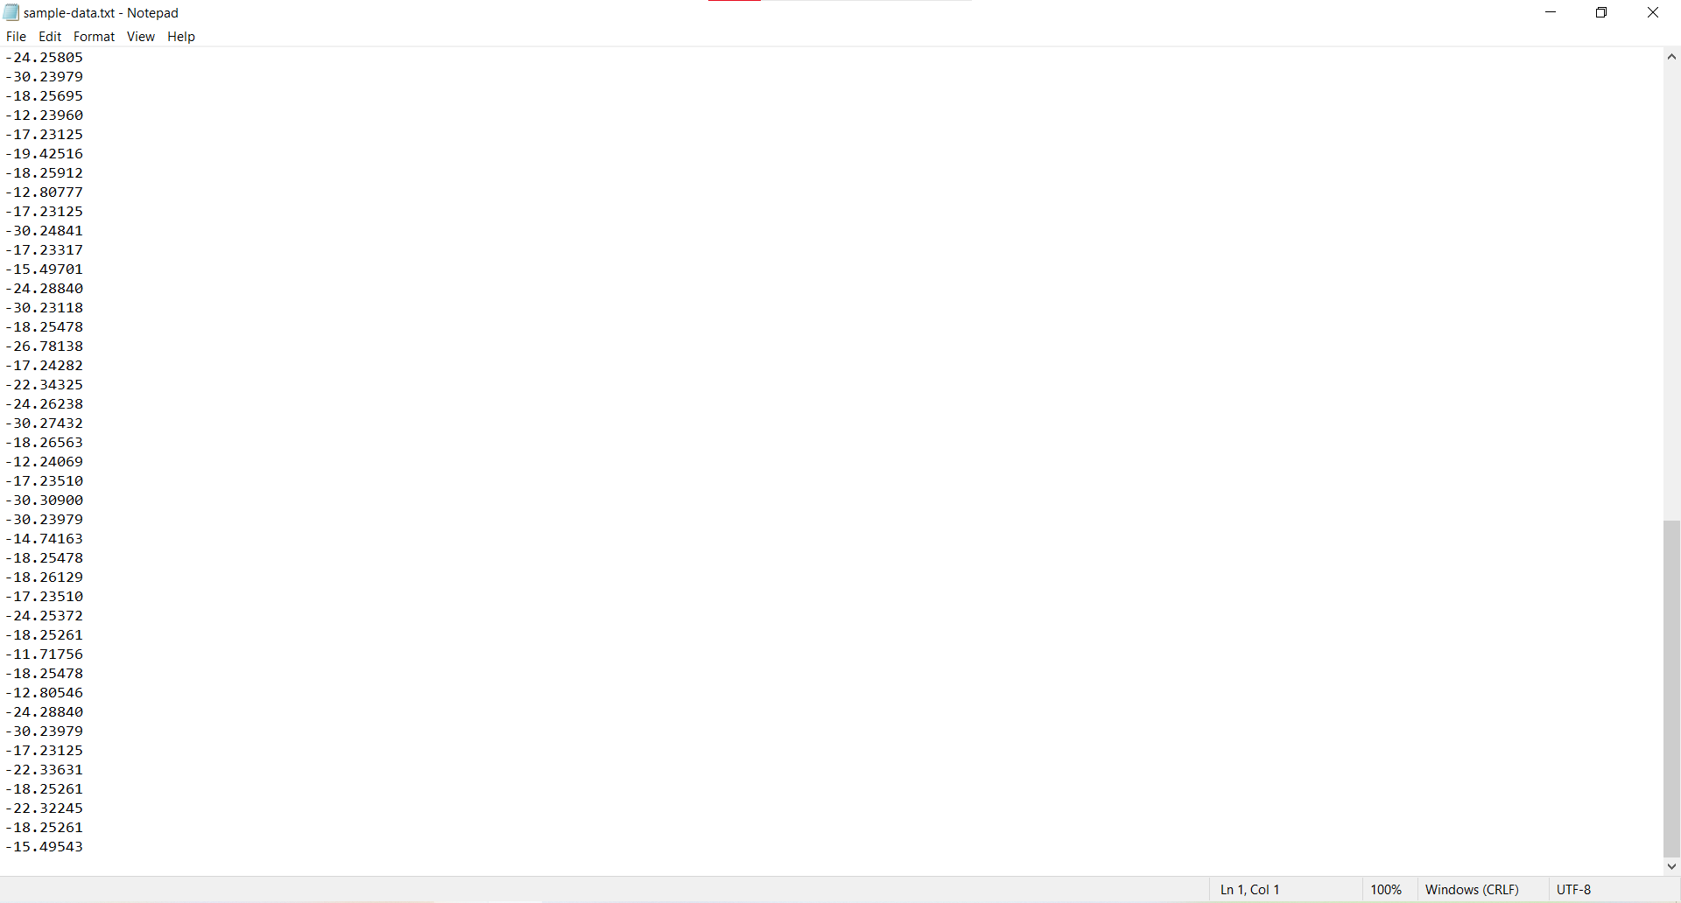

At this point, I was unsure of where to move forward, so I followed [this writeup](https://picoctf2021.haydenhousen.com/forensics/surfing-the-waves).

picoCTF{mu21C_1s_1337_b58b4519}

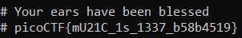

**Where are the robots?**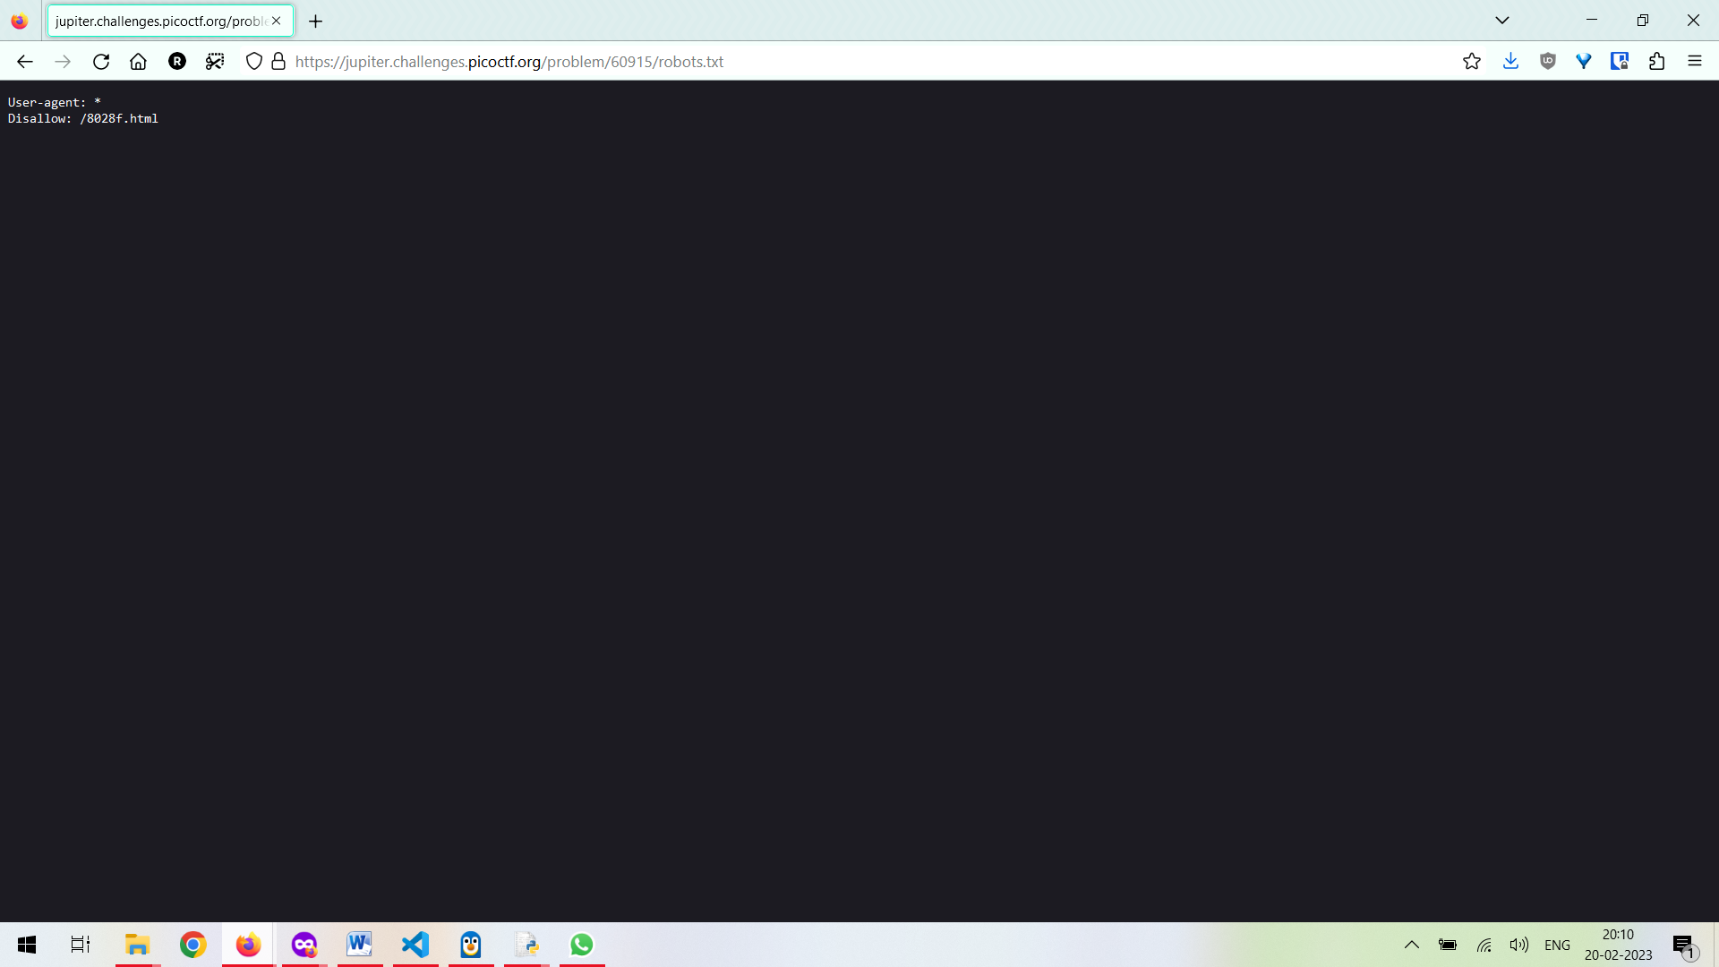

Robots.txt is in the name itself so that was the first thing to do.

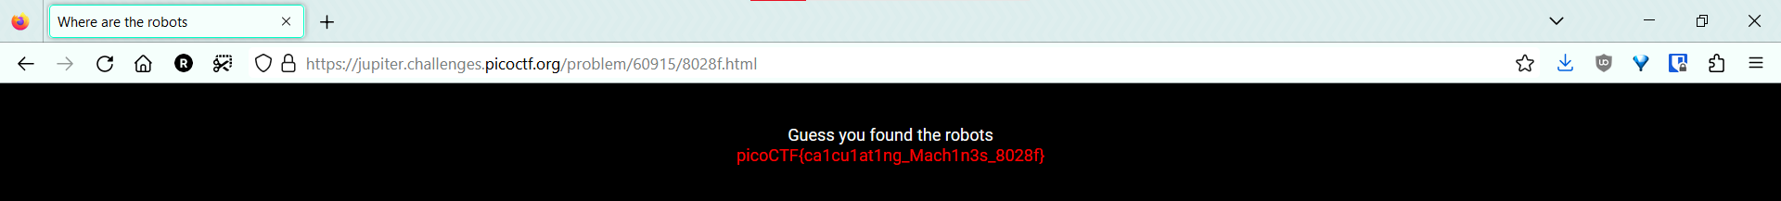

picoCTF{ca1cu1at1ng_Mach1n3s_8028f}

**Inspector HTML**

Again, clue in the name. Opened up inspect element, and got the flag

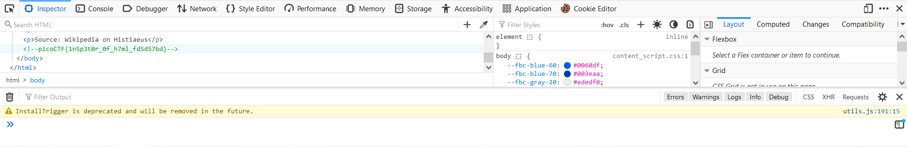

picoCTF{1n5p3t0r_0f_h7ml_fd5d57bd}

**information**

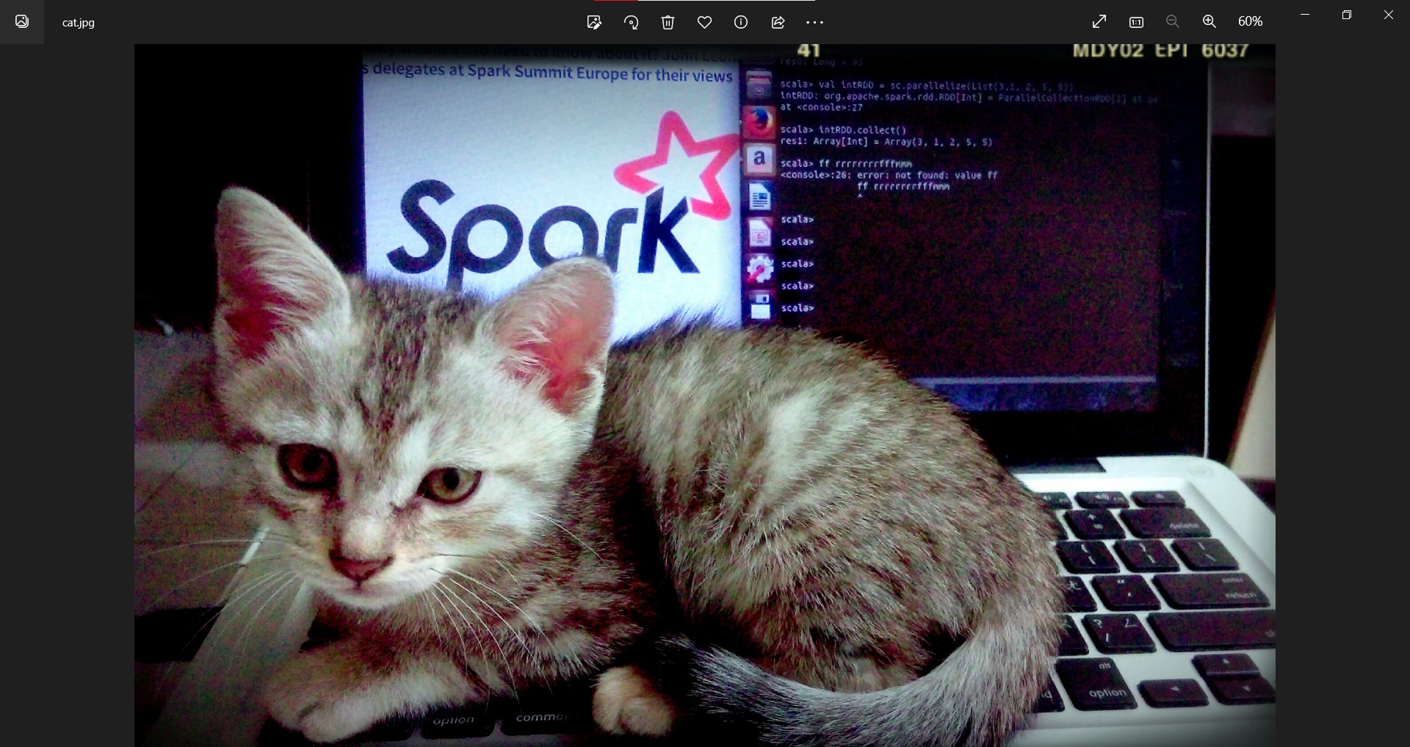

I tried binwalk, but nothing showed up.

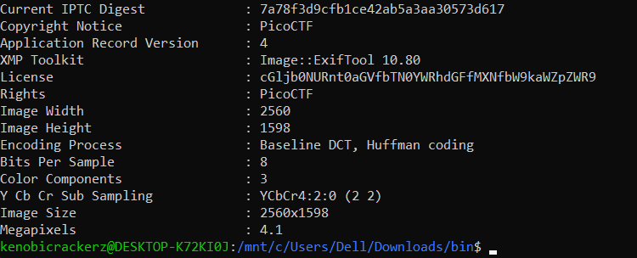

IPTC digest and License look like they might be useful.

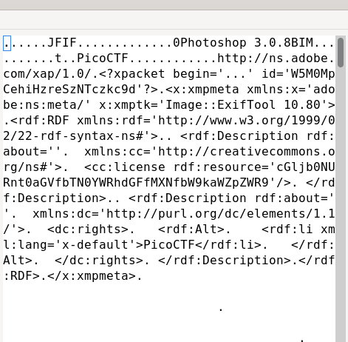

I ran them through a multi-decoder and the second one

“cGljb0NURnt0aGVfbTN0YWRhdGFfMXNfbW9kaWZpZWR9” gave me the flag.

picoCTF{the_m3tadata_1s_modified} 